**Assignment: 1**

Create a Git repository for a simple project of your choice (e.g., a website, a blog, a command-line utility, etc.) and complete the following tasks:

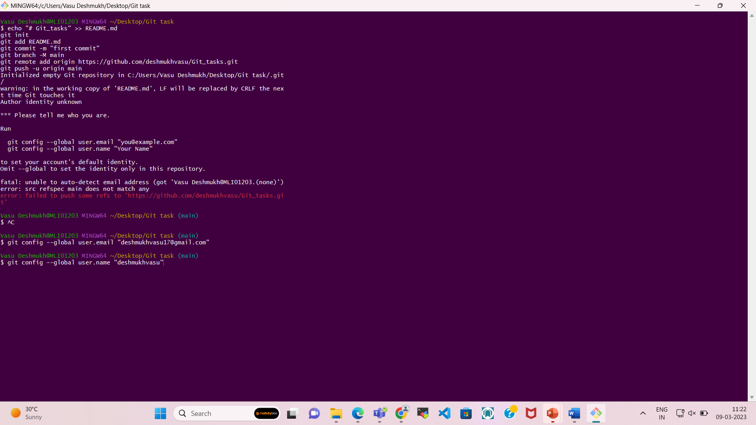

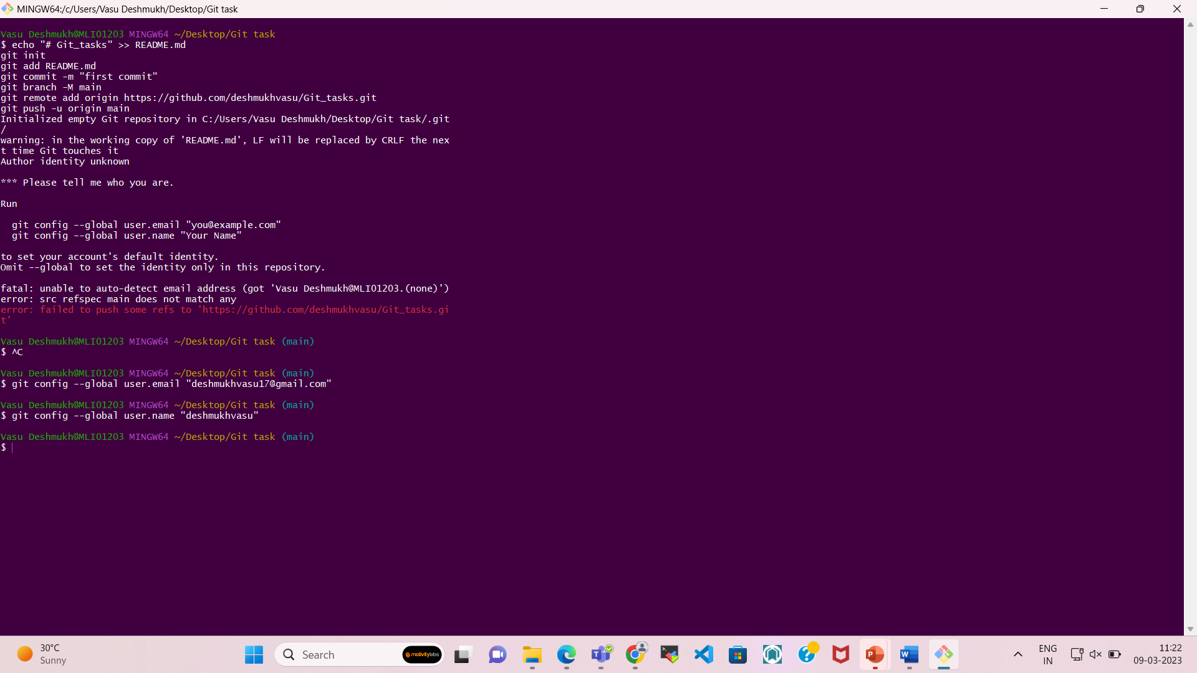

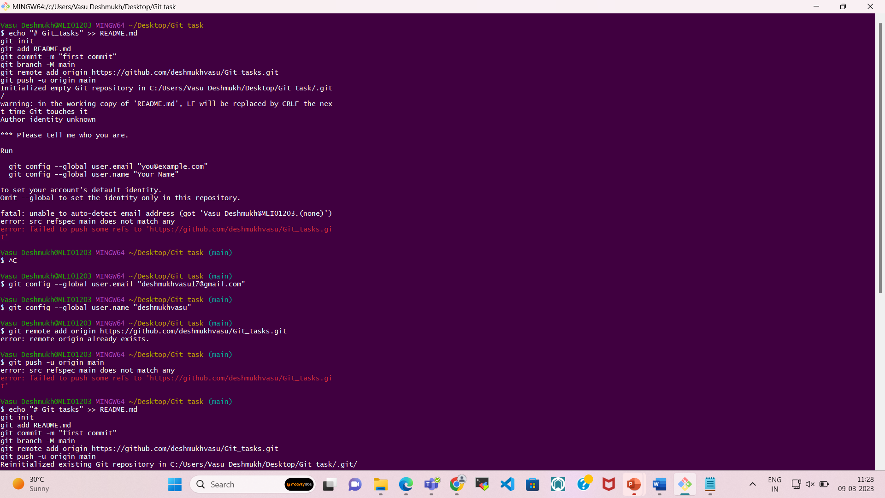

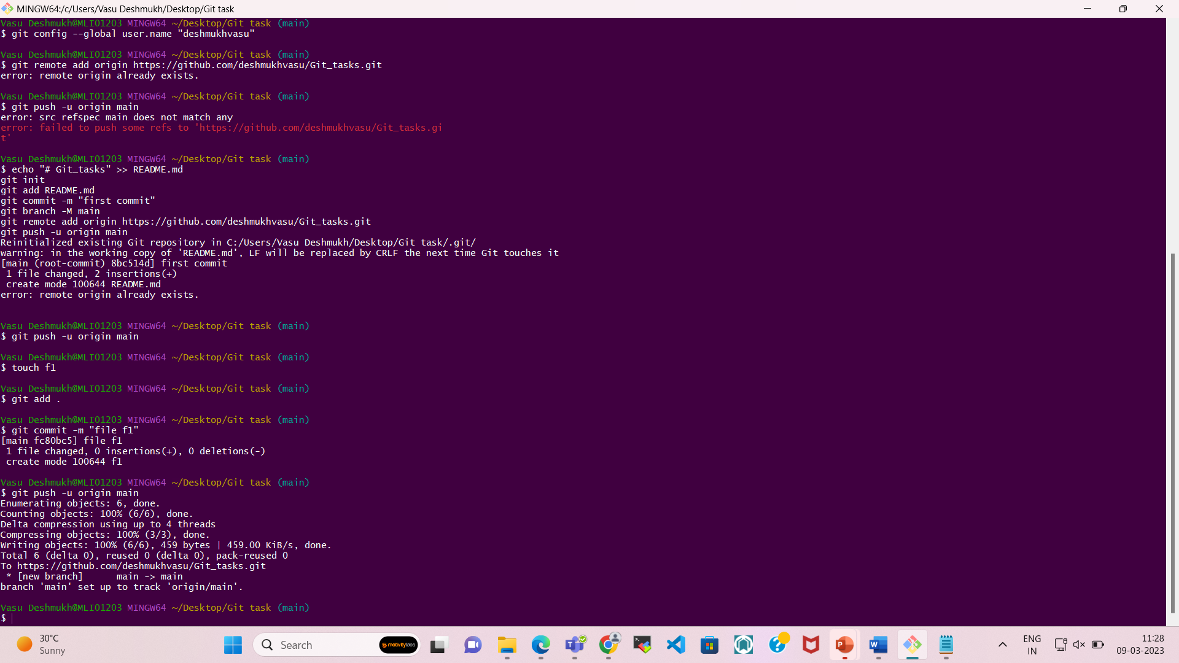

**To verify from the GITHUB**

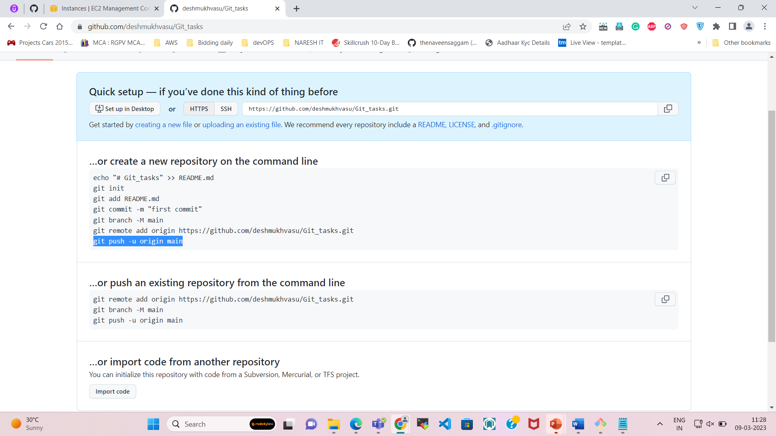

You can see I have pushed 1 file from my local machine.

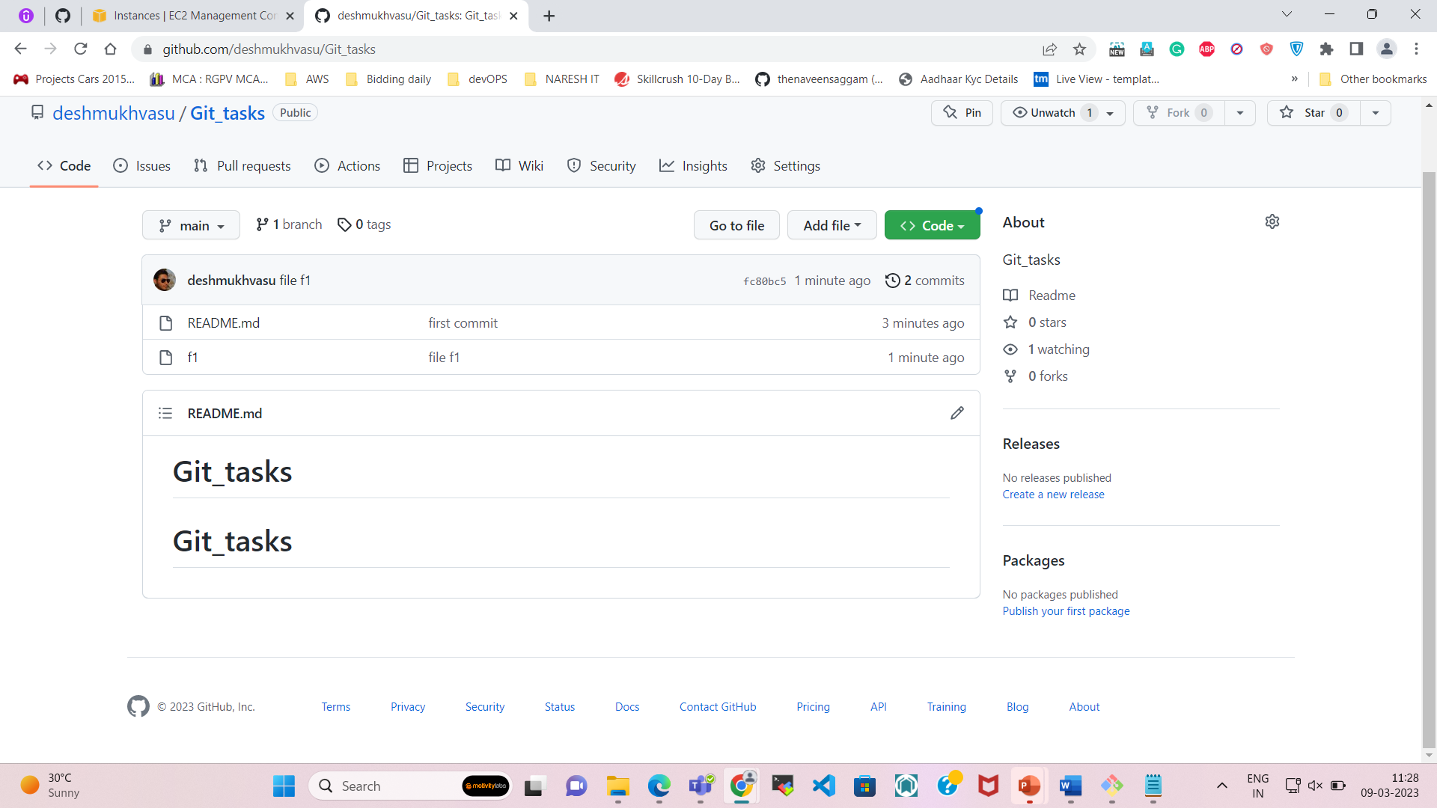

1. Create a branch for development and switch to that branch.

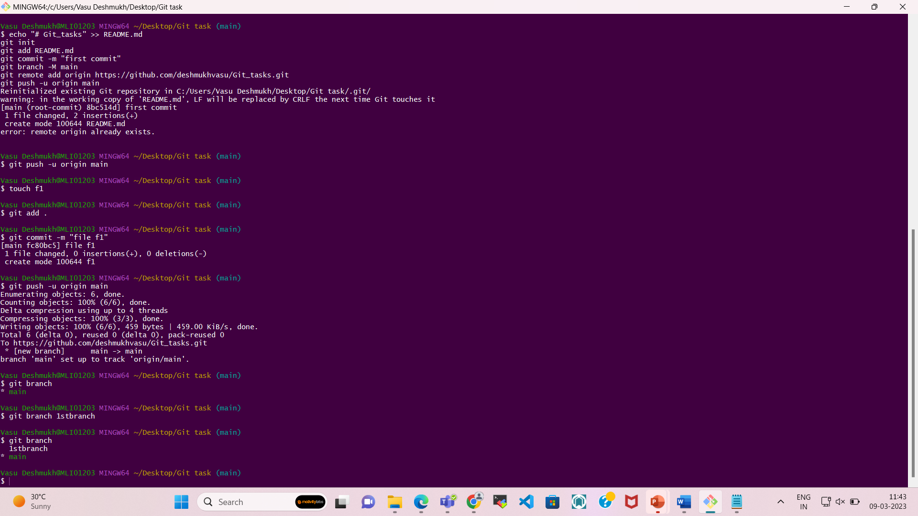

Now switching into the new branch

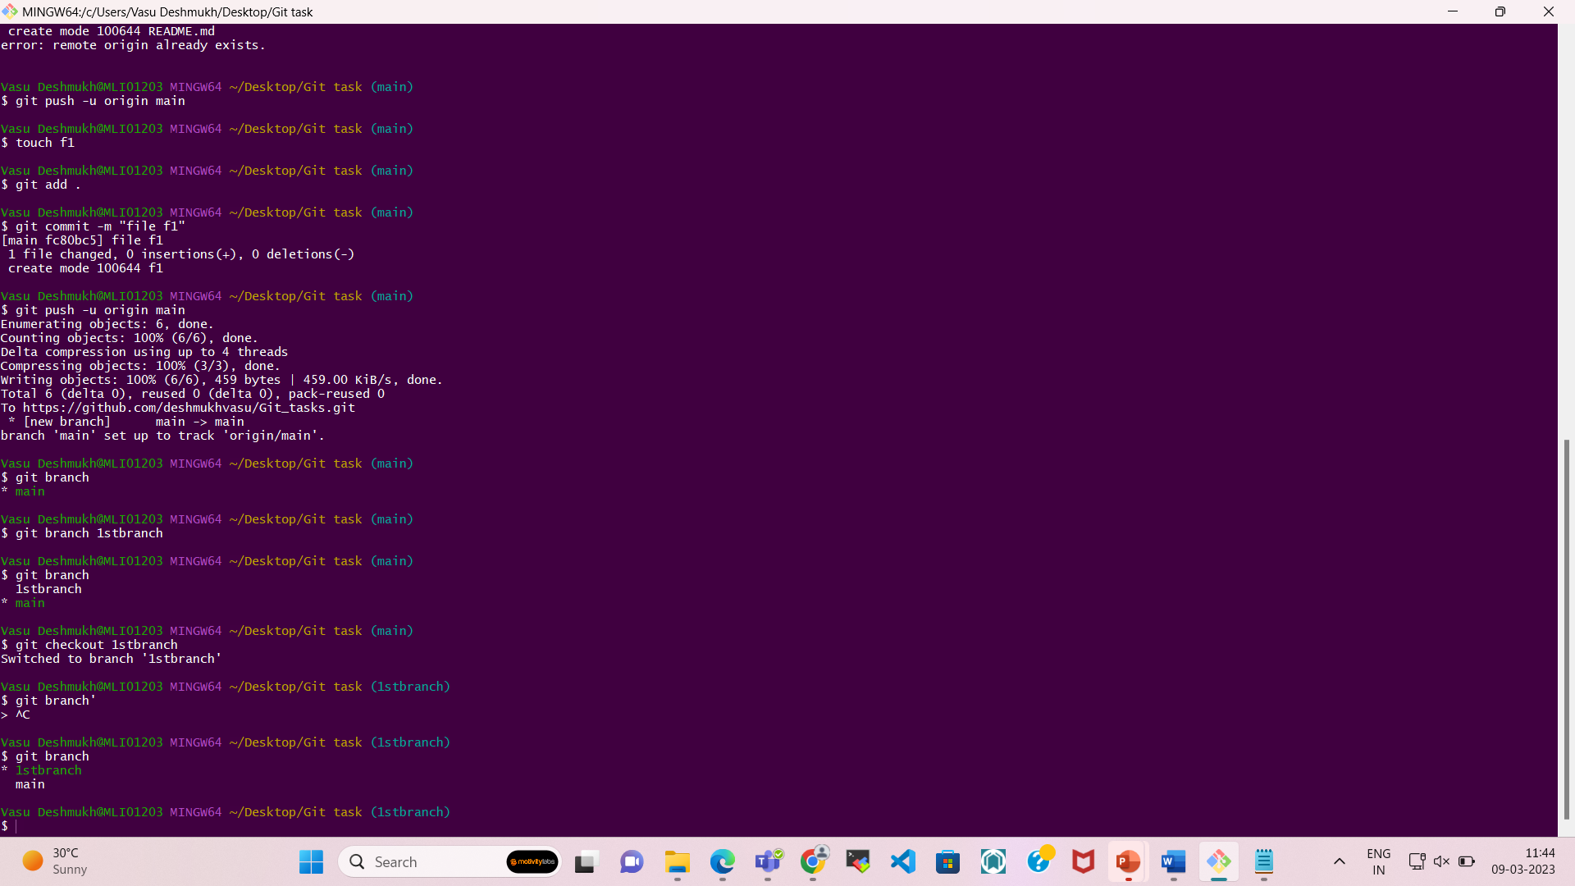

2. Create a file in the repository and add some code to it.

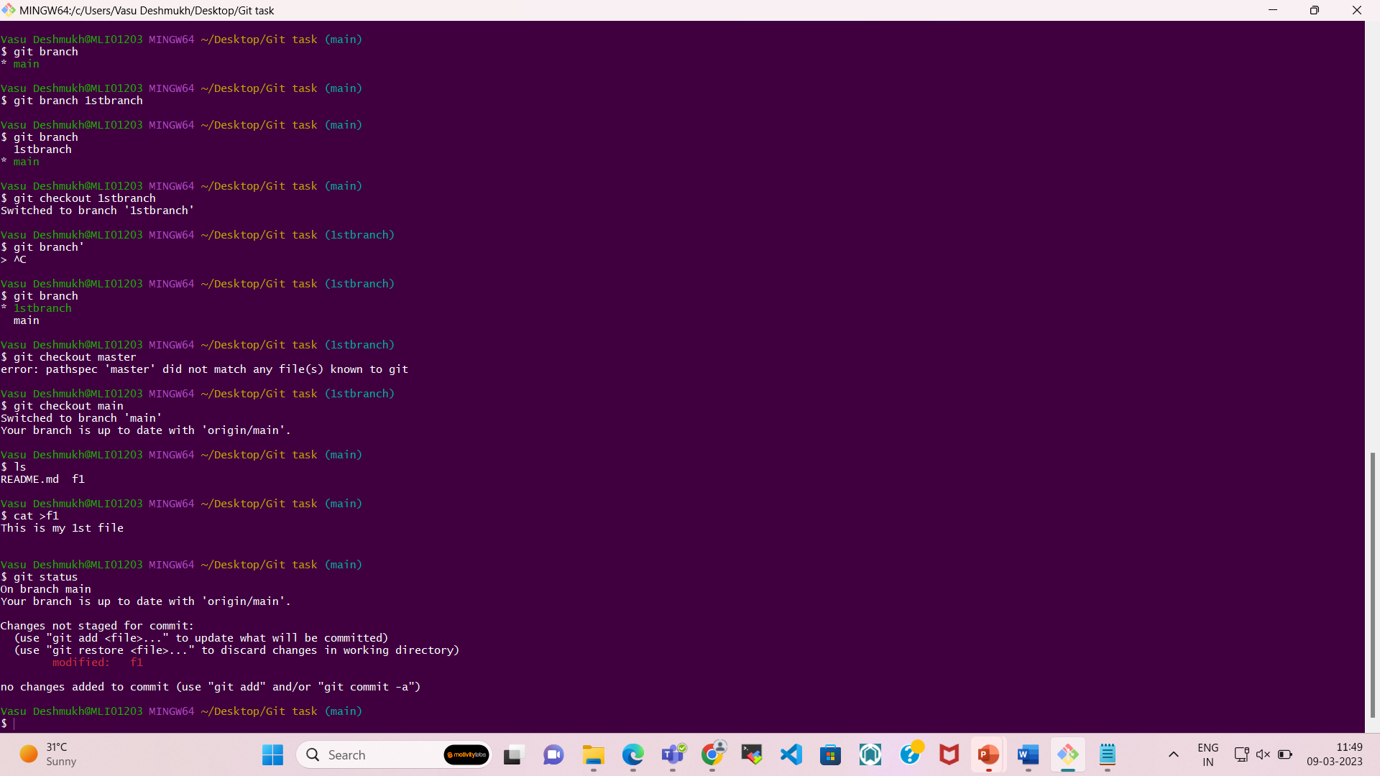

3. Stage the file and commit the changes.

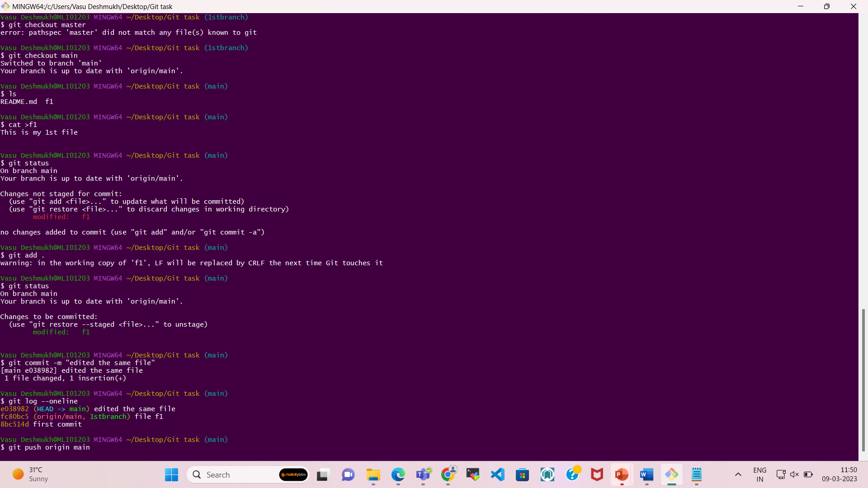

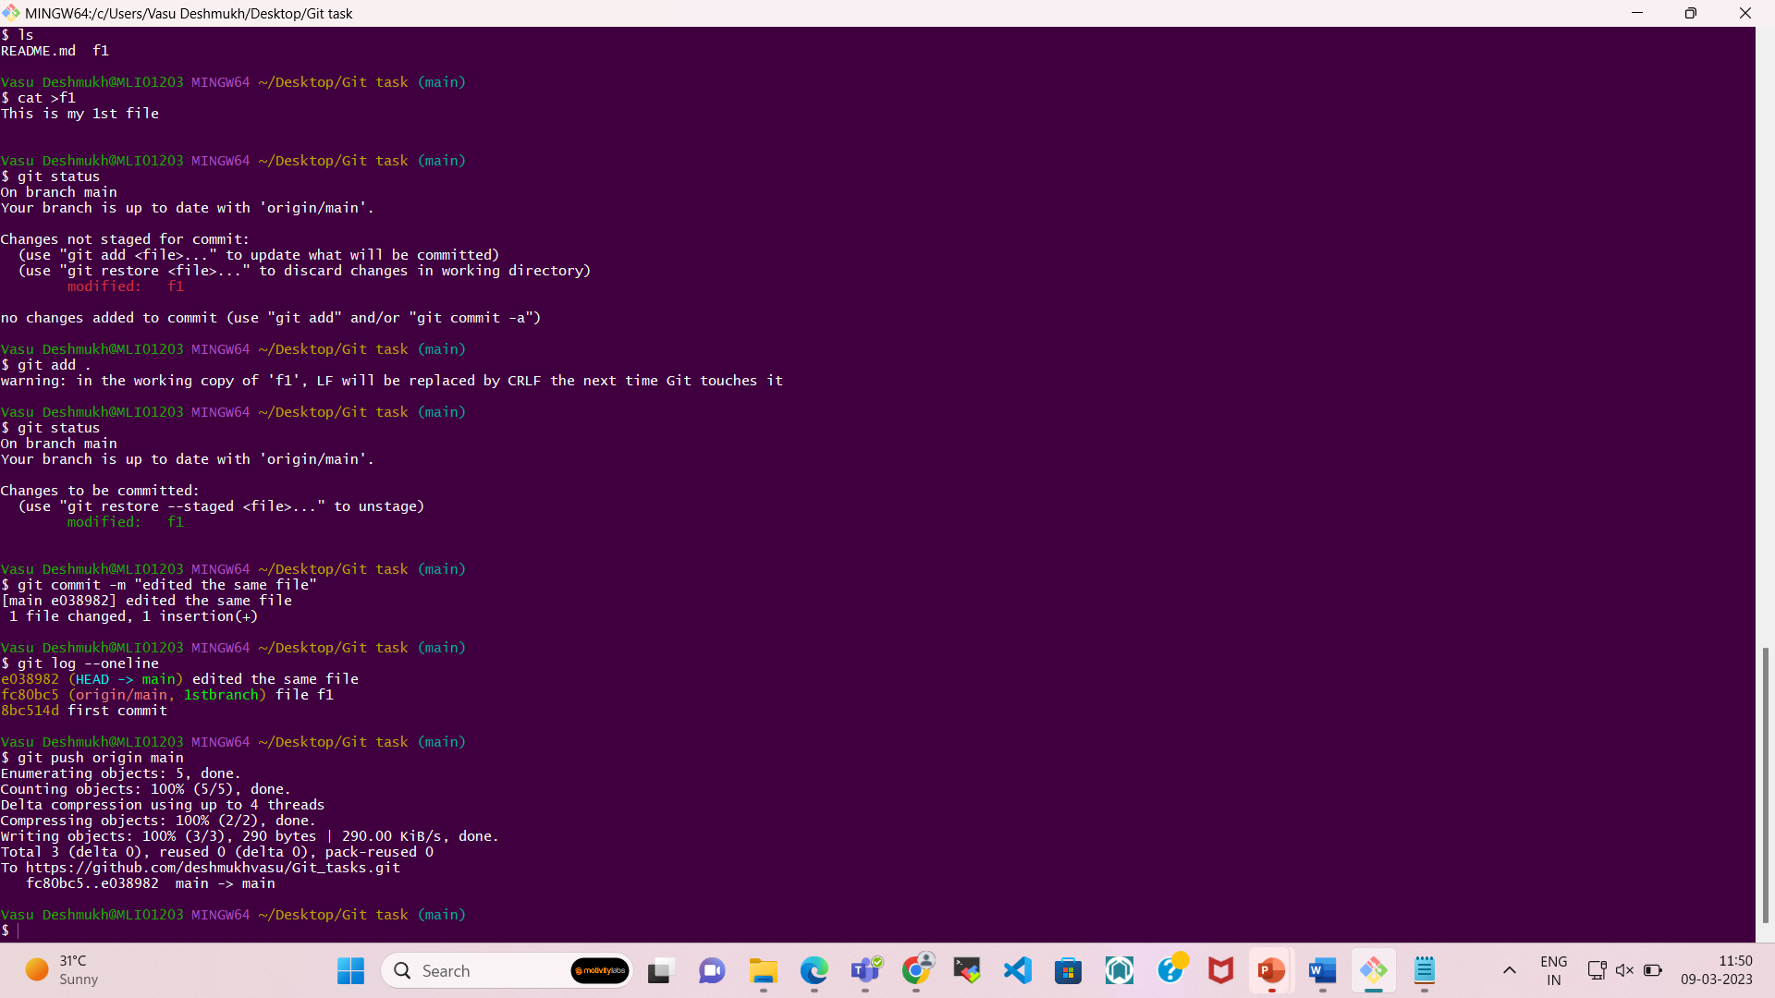

4. Push the branch to a remote repository (such as GitHub).

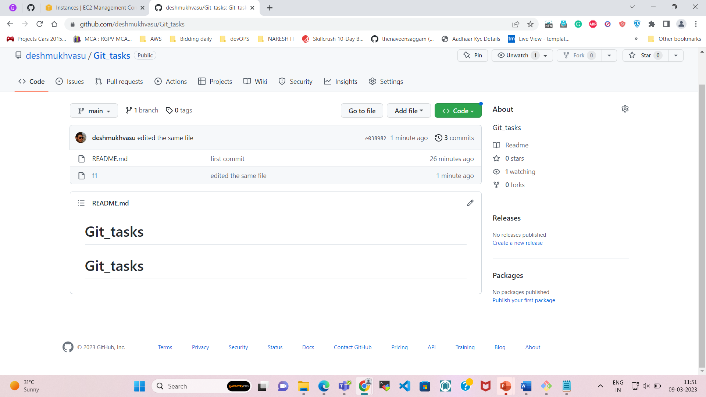

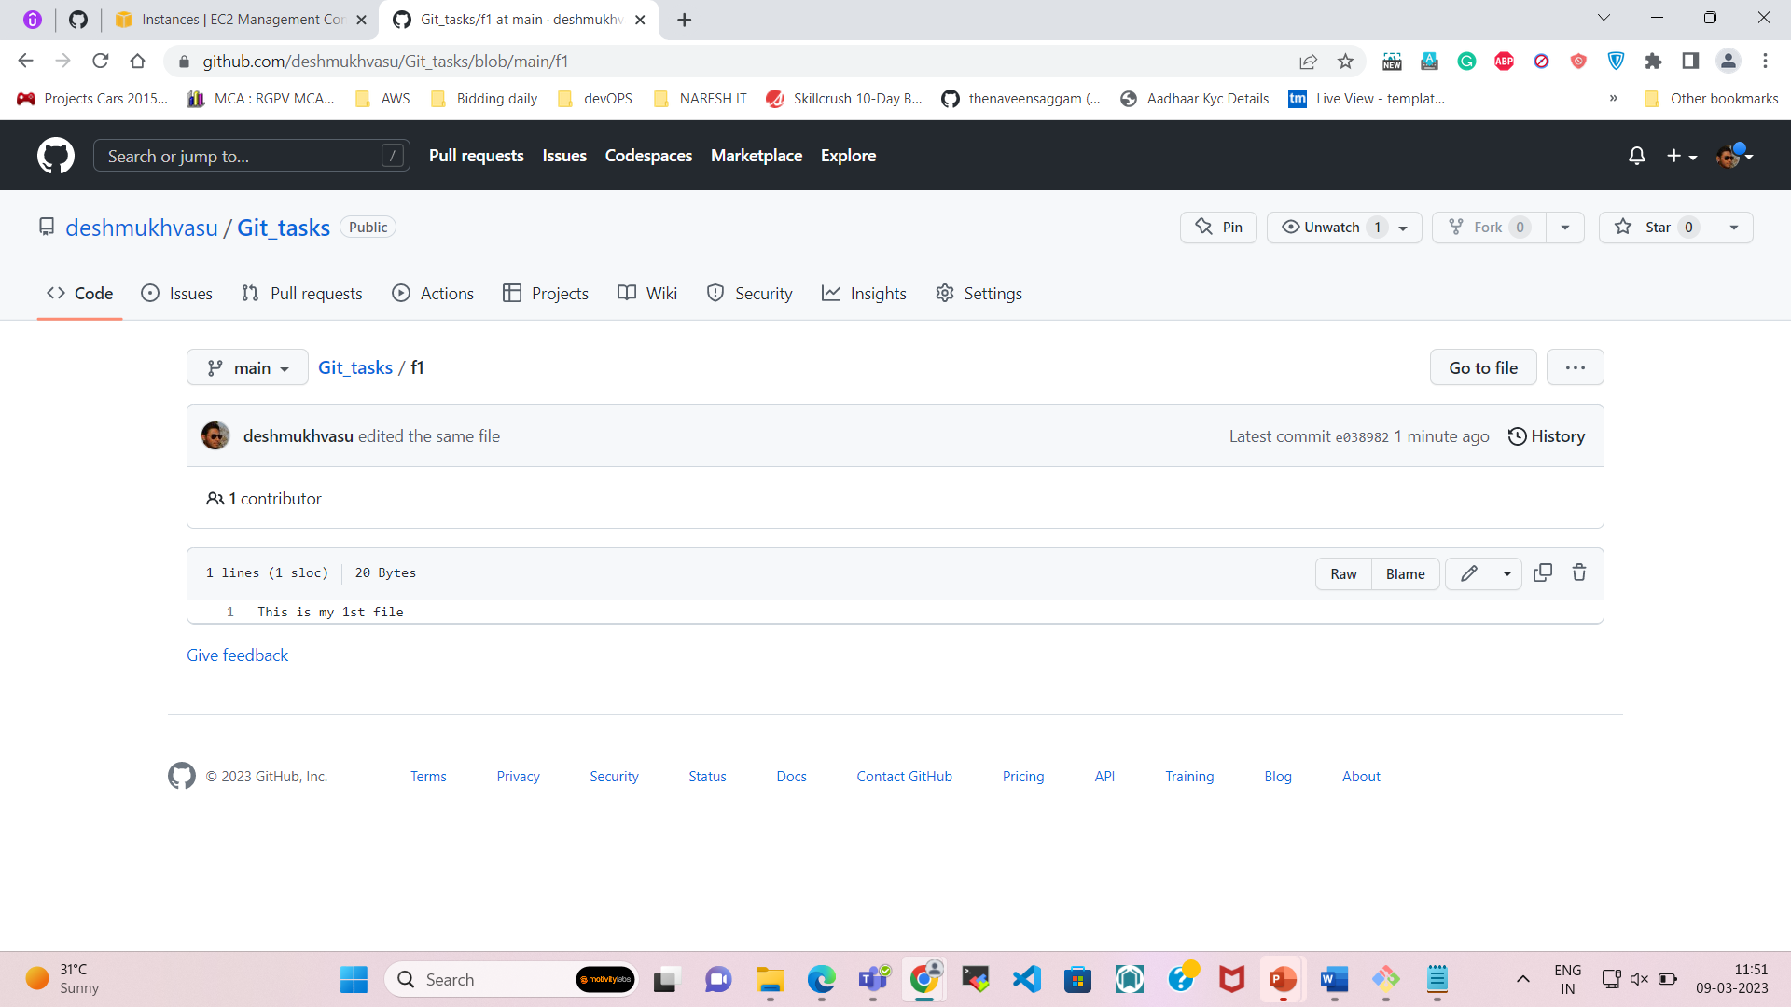

5. Merge the development branch into the main branch.

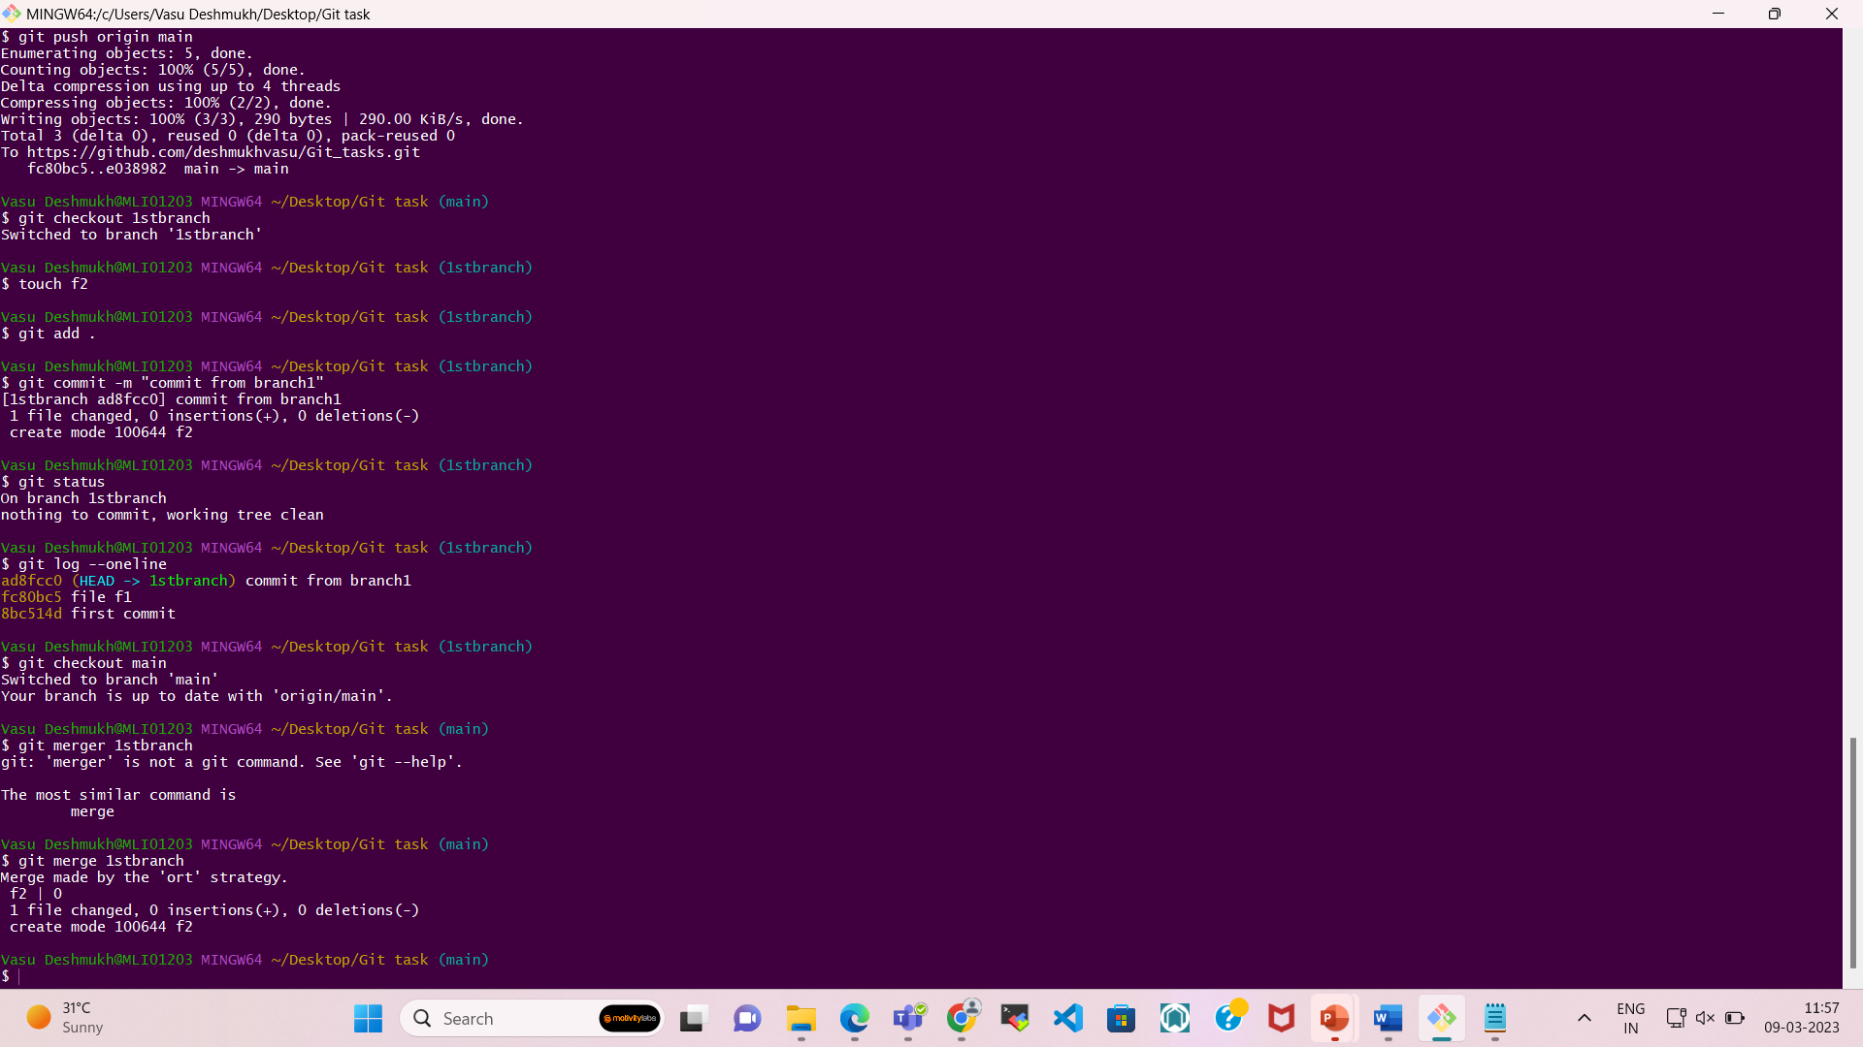

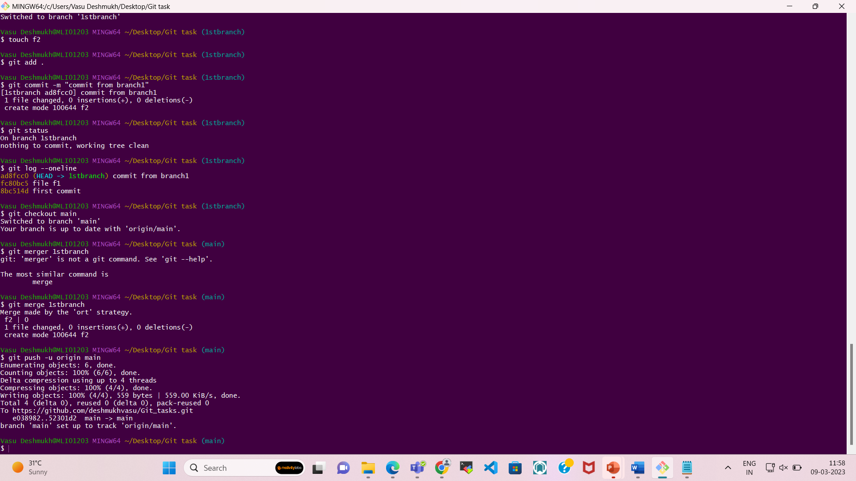

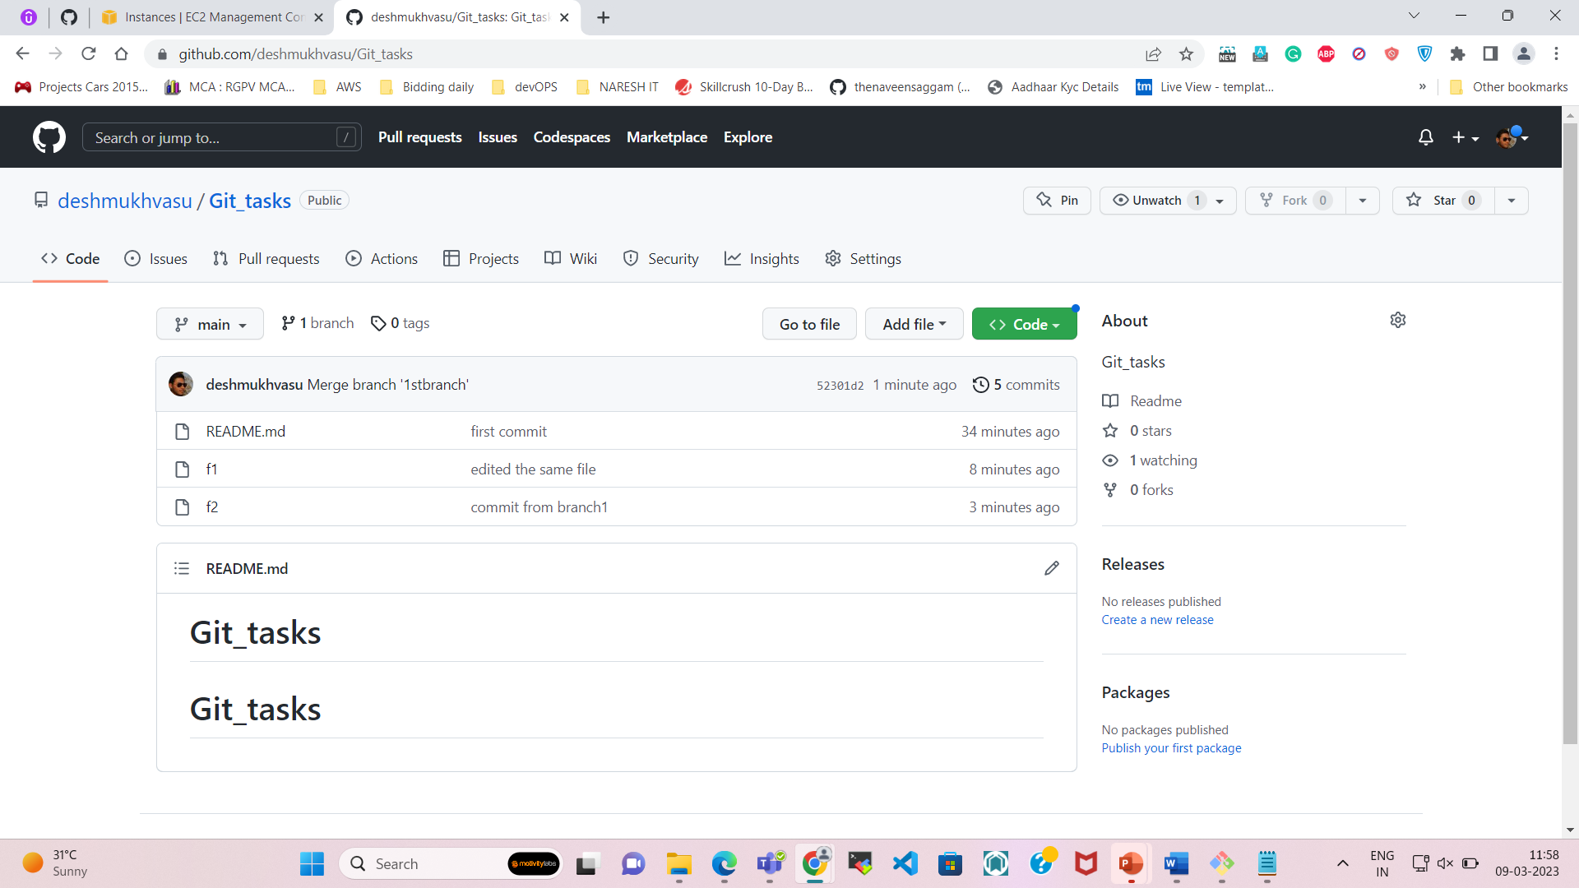

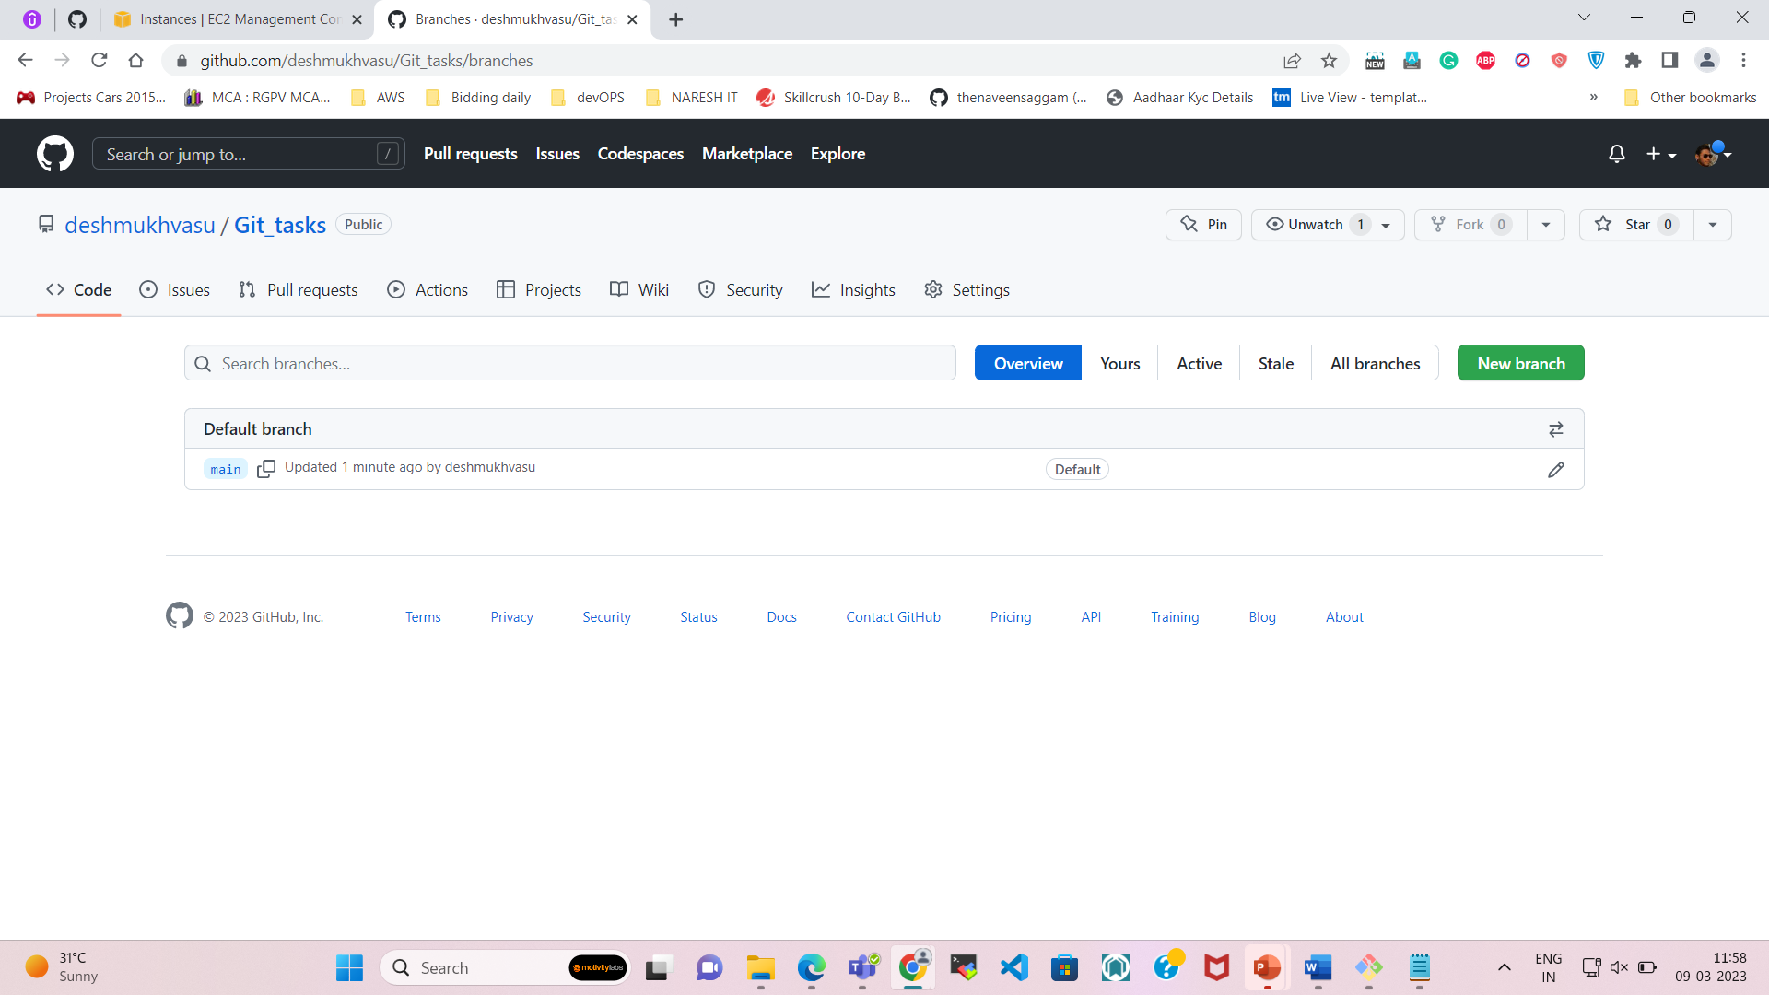

6. Tag the latest commit on the main branch with a version number.

– **git log -1** command to display only the latest commit.

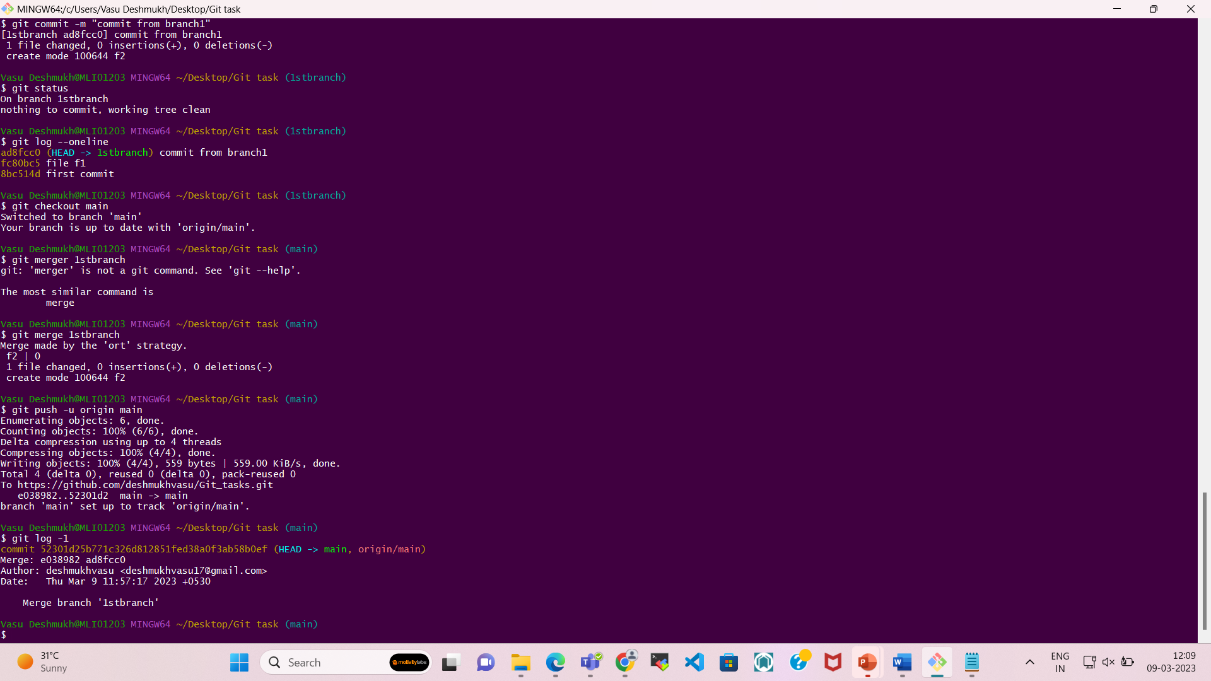

If Tag is not there,1 then we must create the tag by using following command

* **git tag <tagname>**

**For pushing the tags, we must use the command**

* **git push --tags**

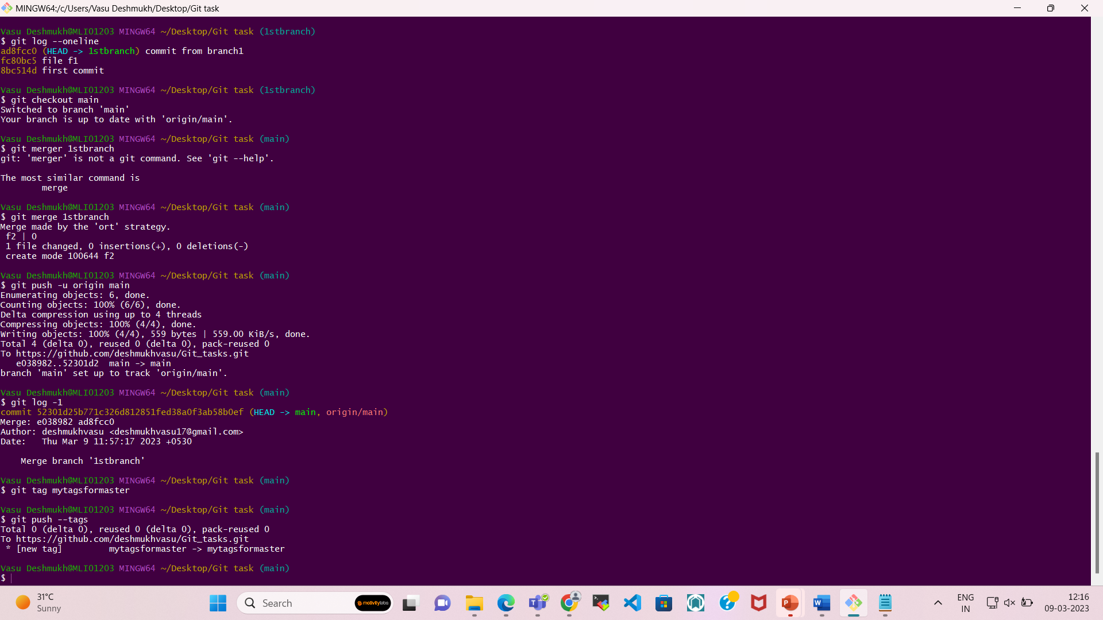

We can check from the GITHUB

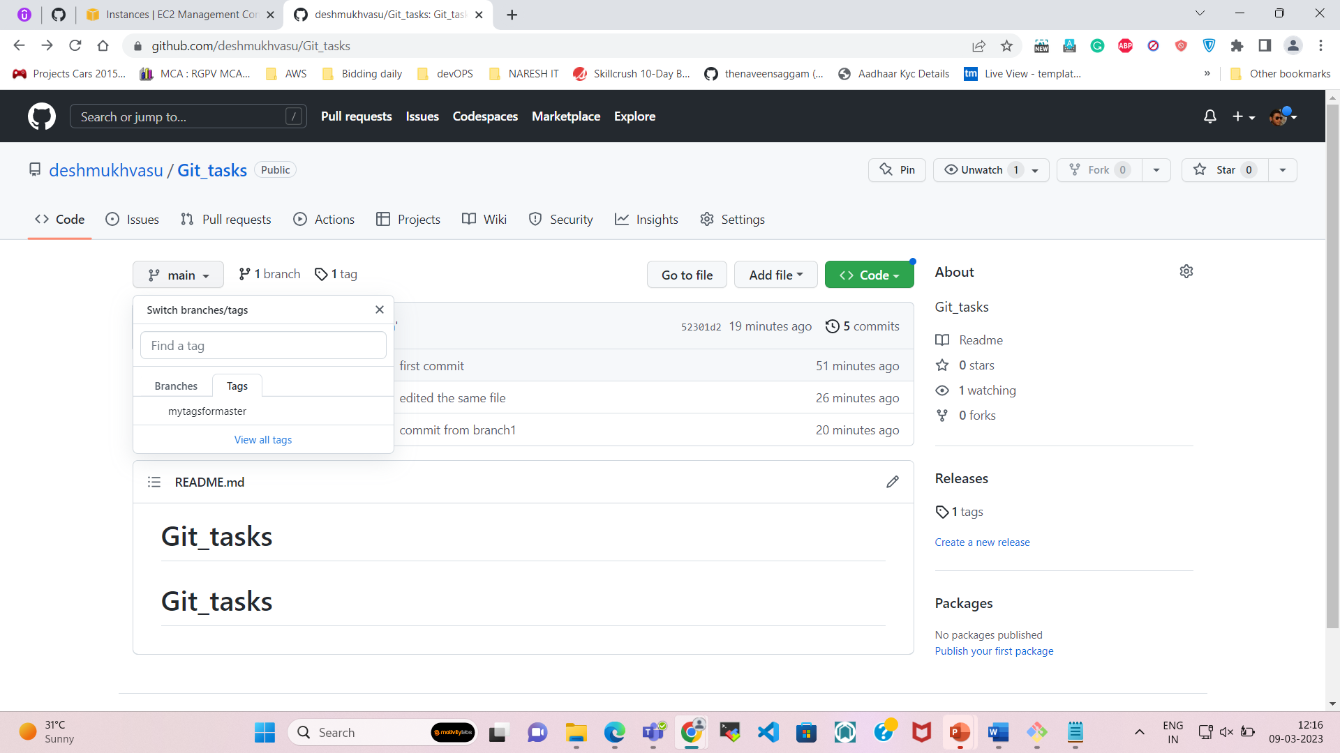

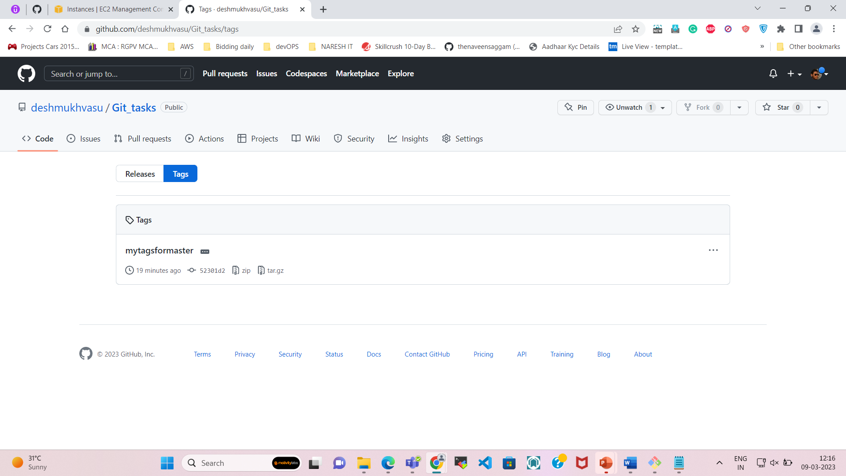

7. Create another branch for a new feature and switch to that branch.

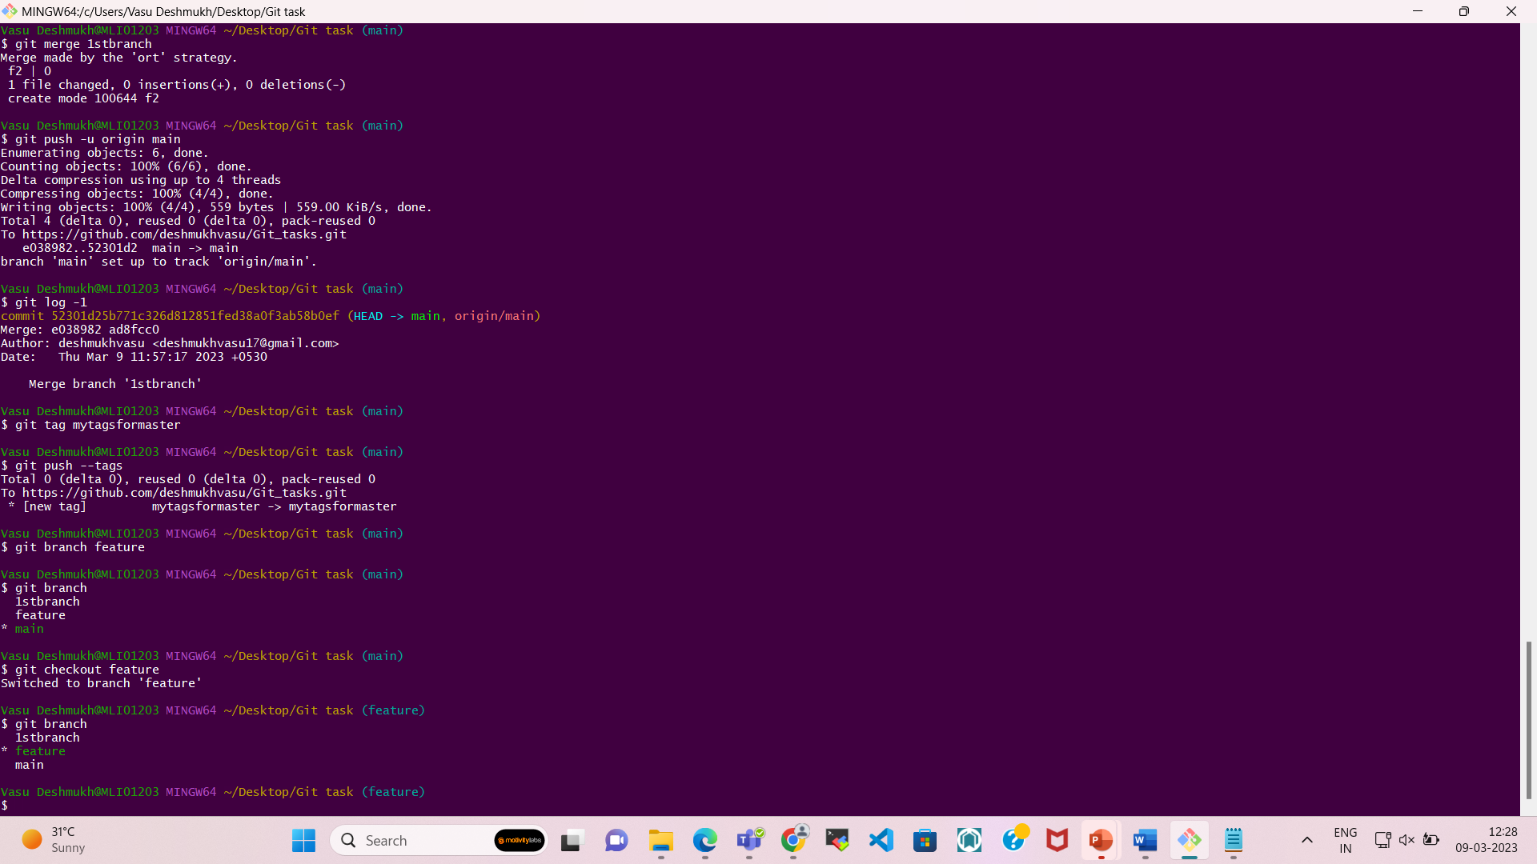

8. Make some changes to the code in the new branch.

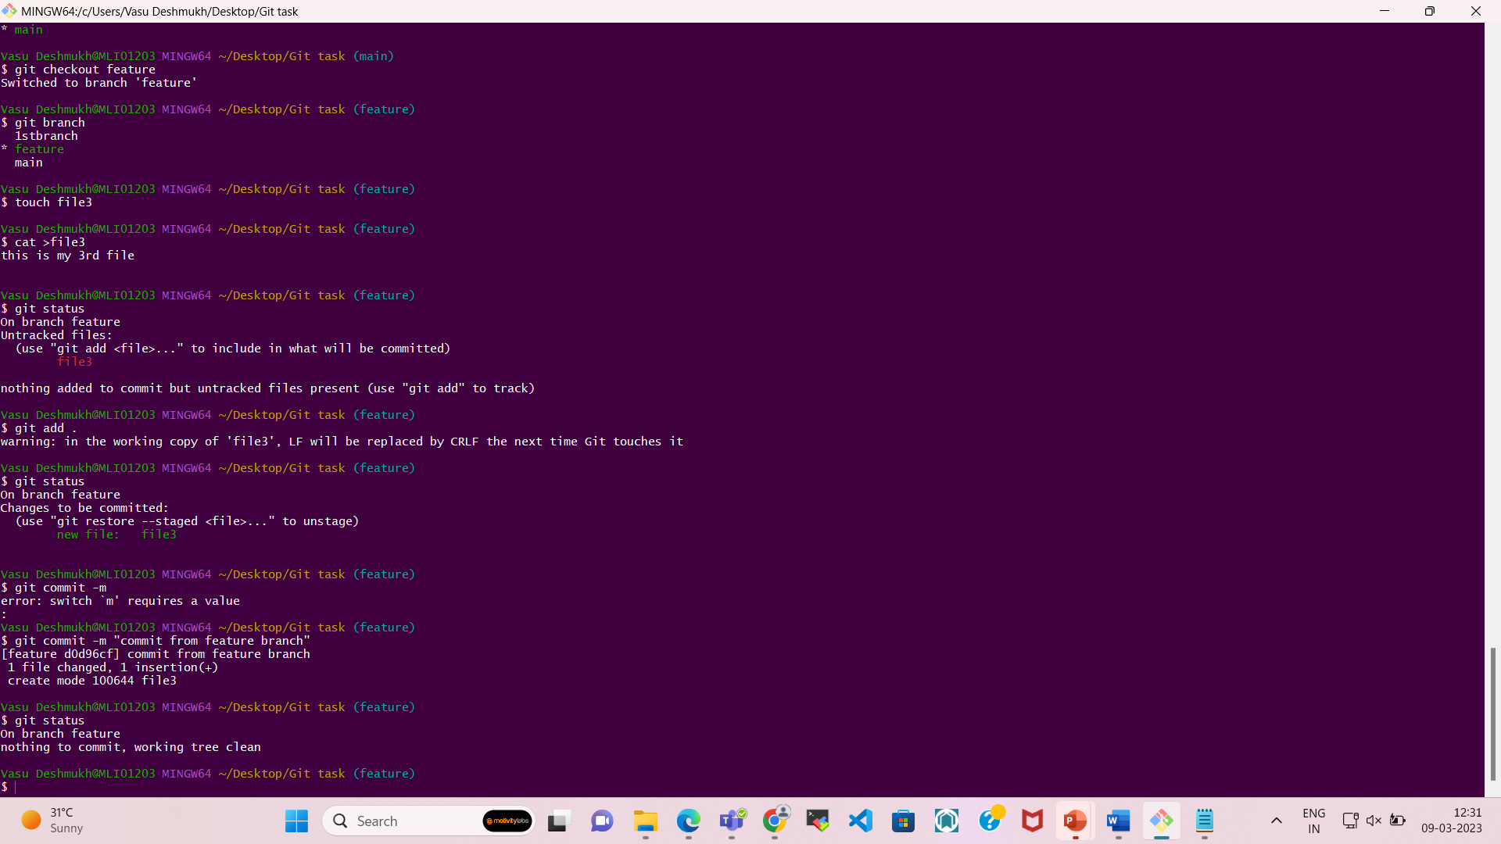

9. Stage the changes and commit them.



10. Push the new branch to the remote repository.

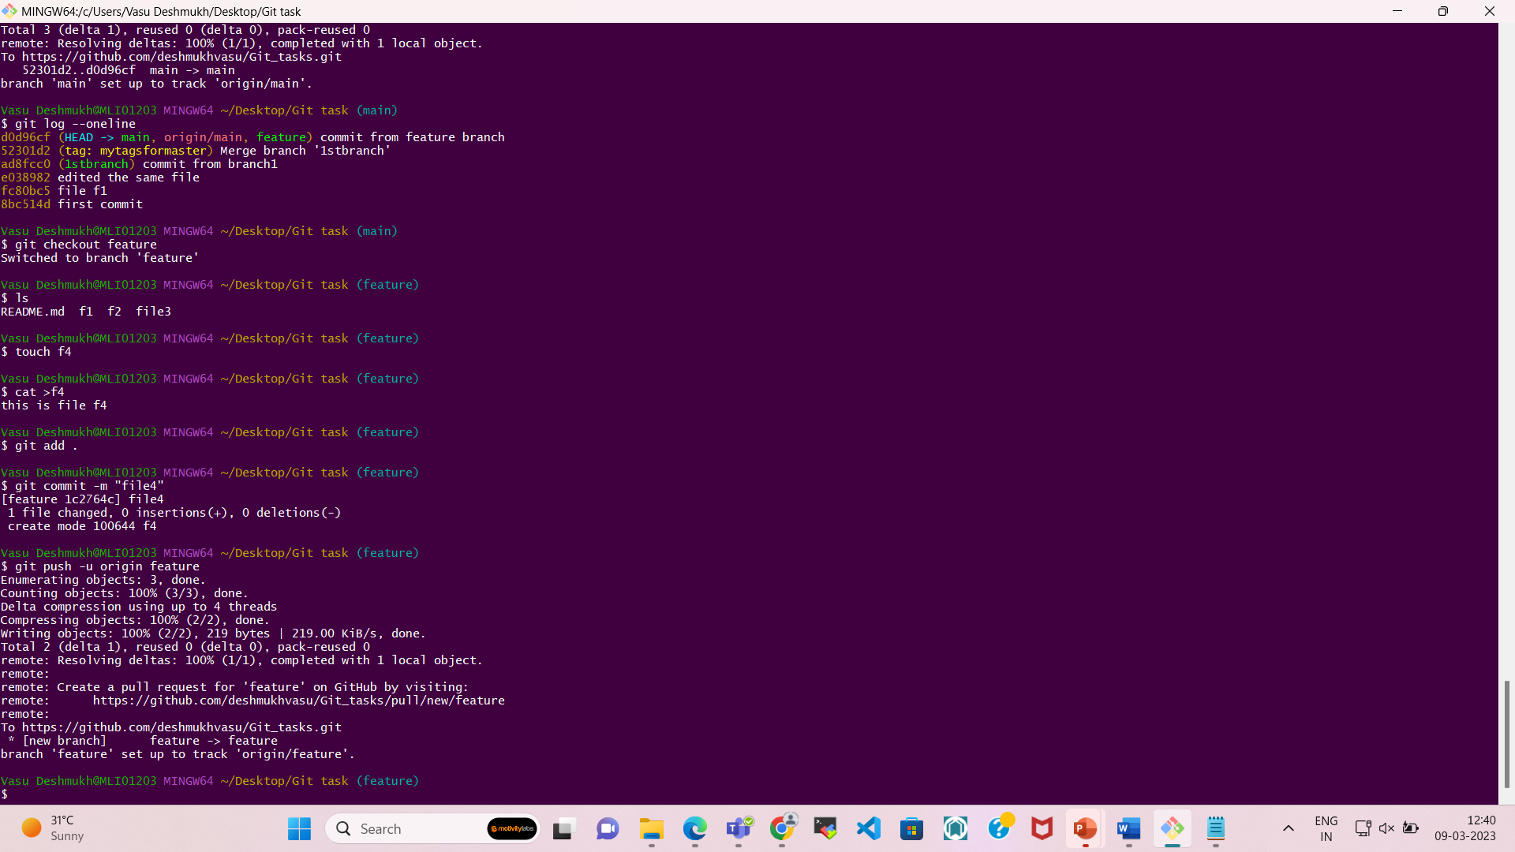

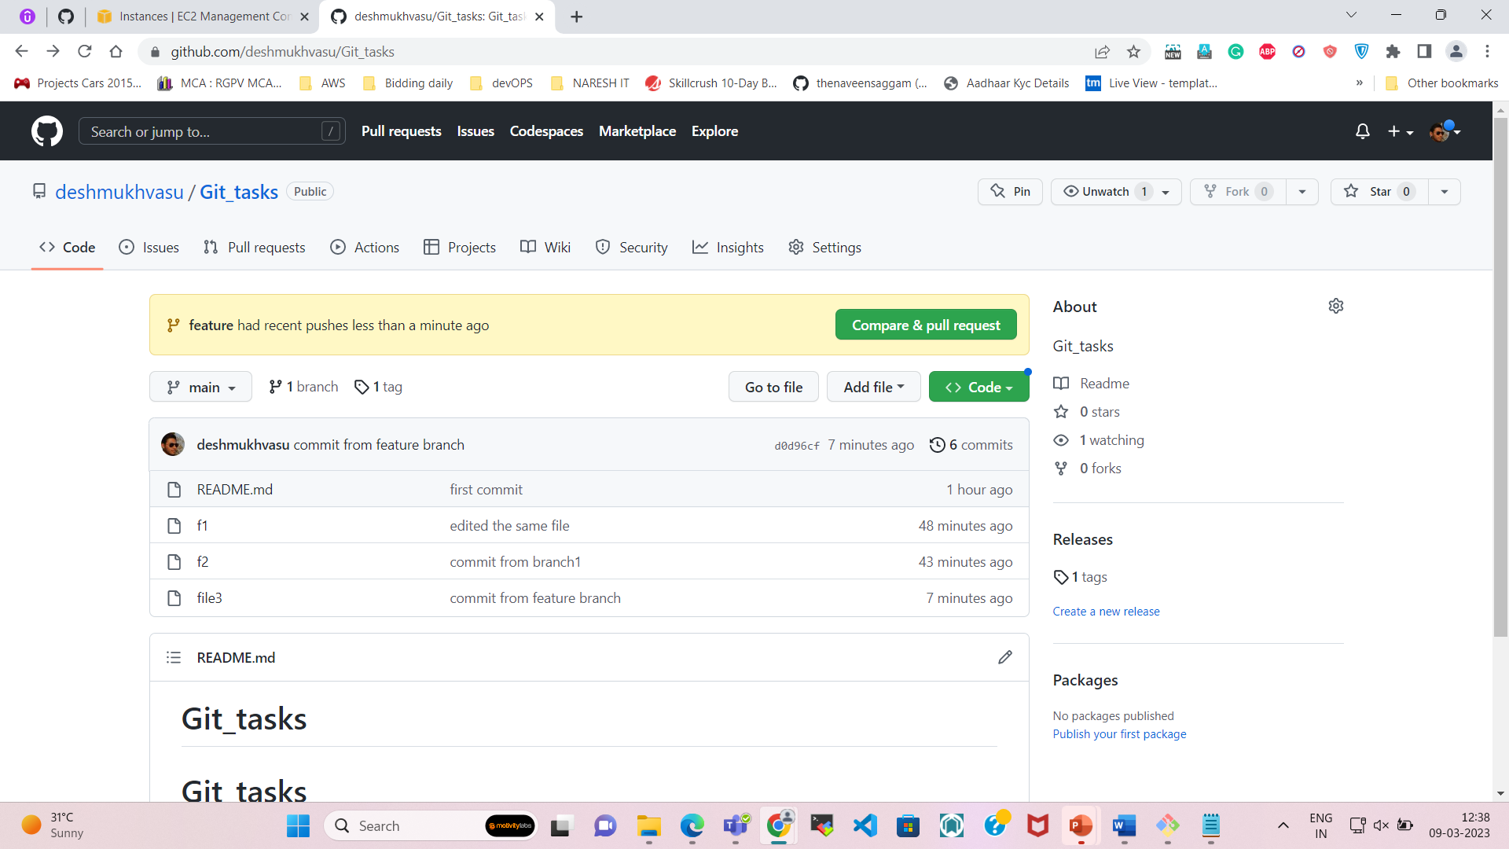

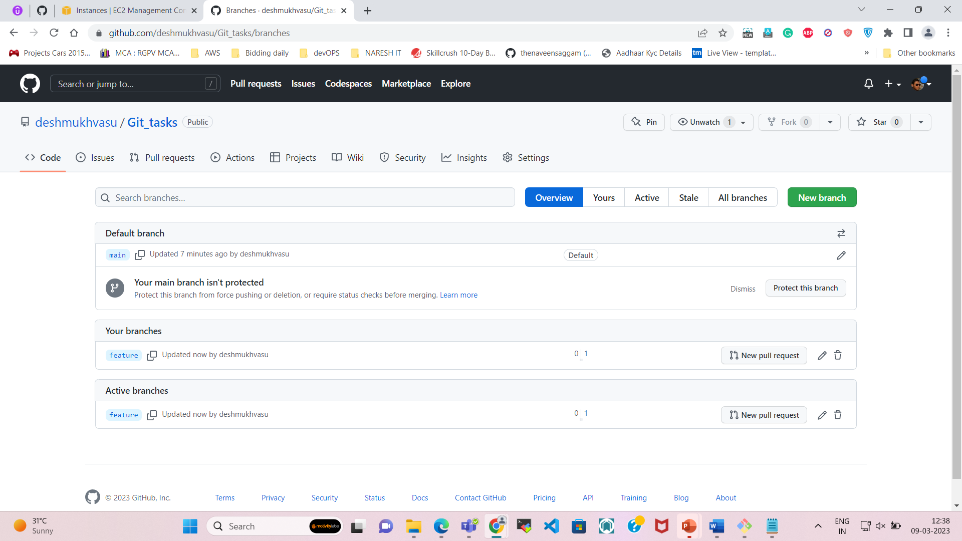

11. Open a pull request to merge the new branch into the main branch.

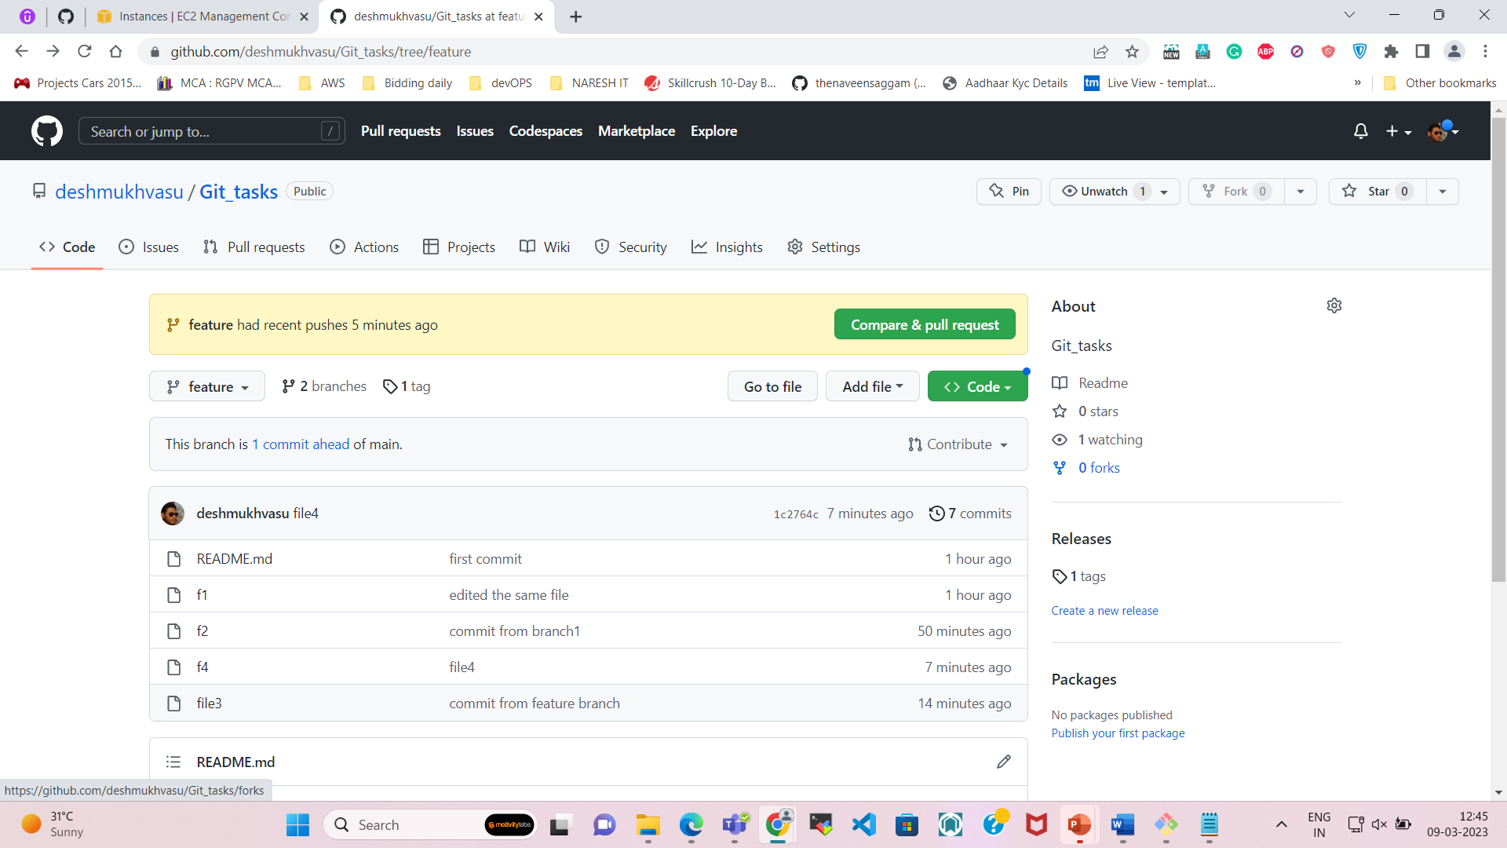

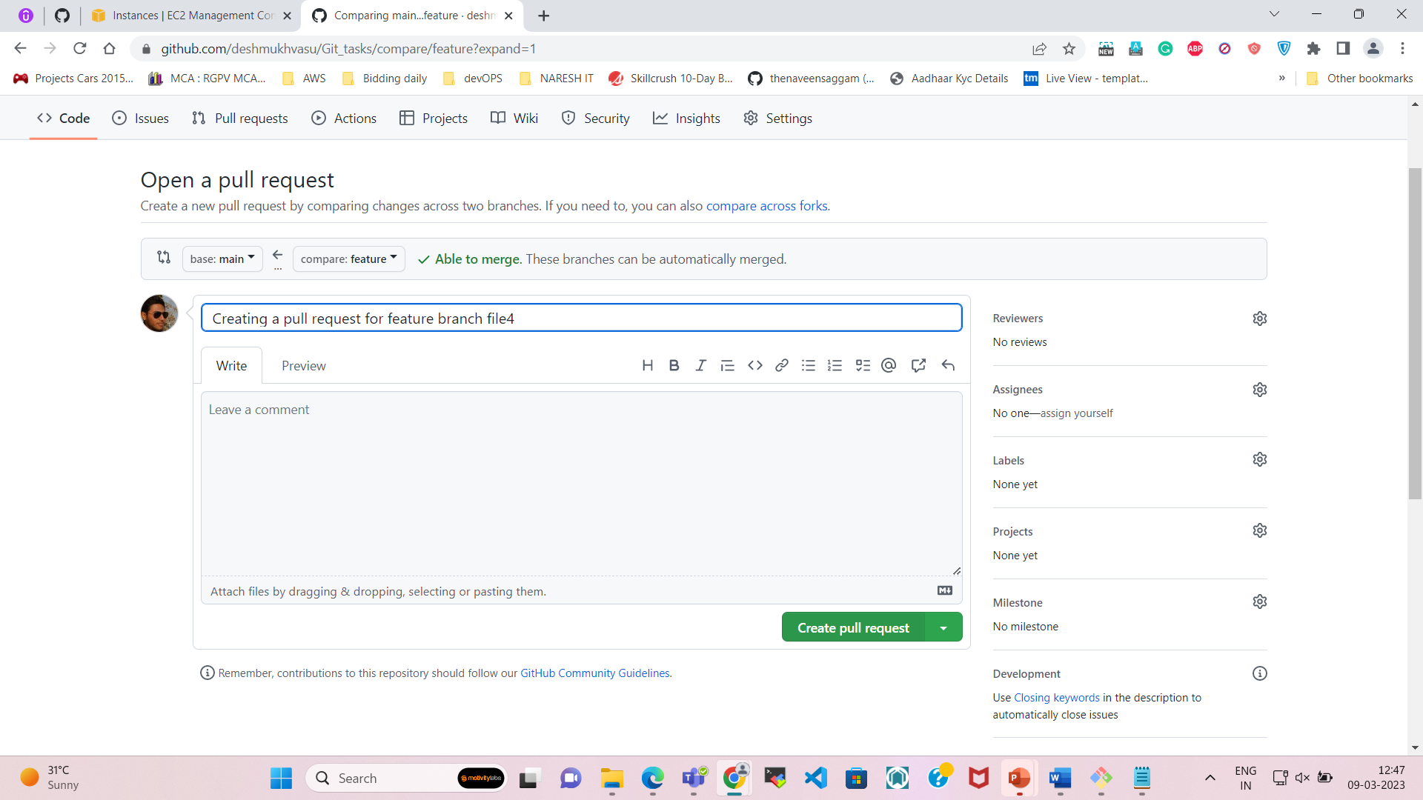

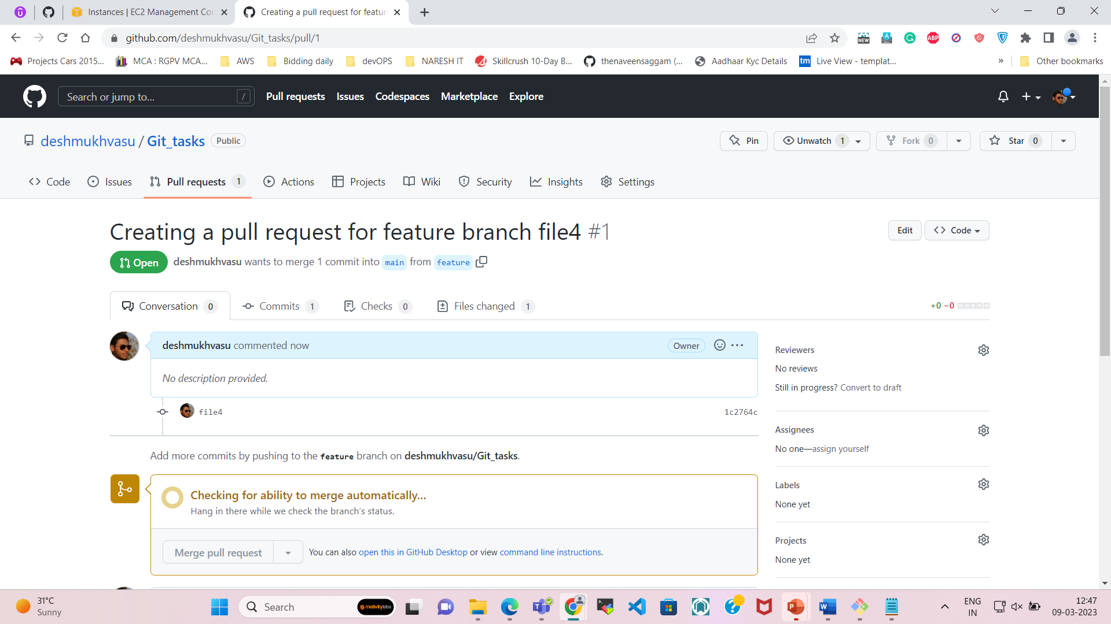

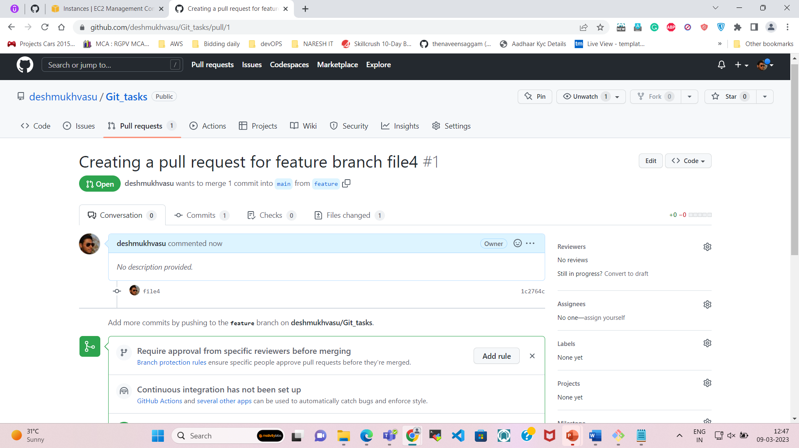

12. Resolve any conflicts and merge the pull request.

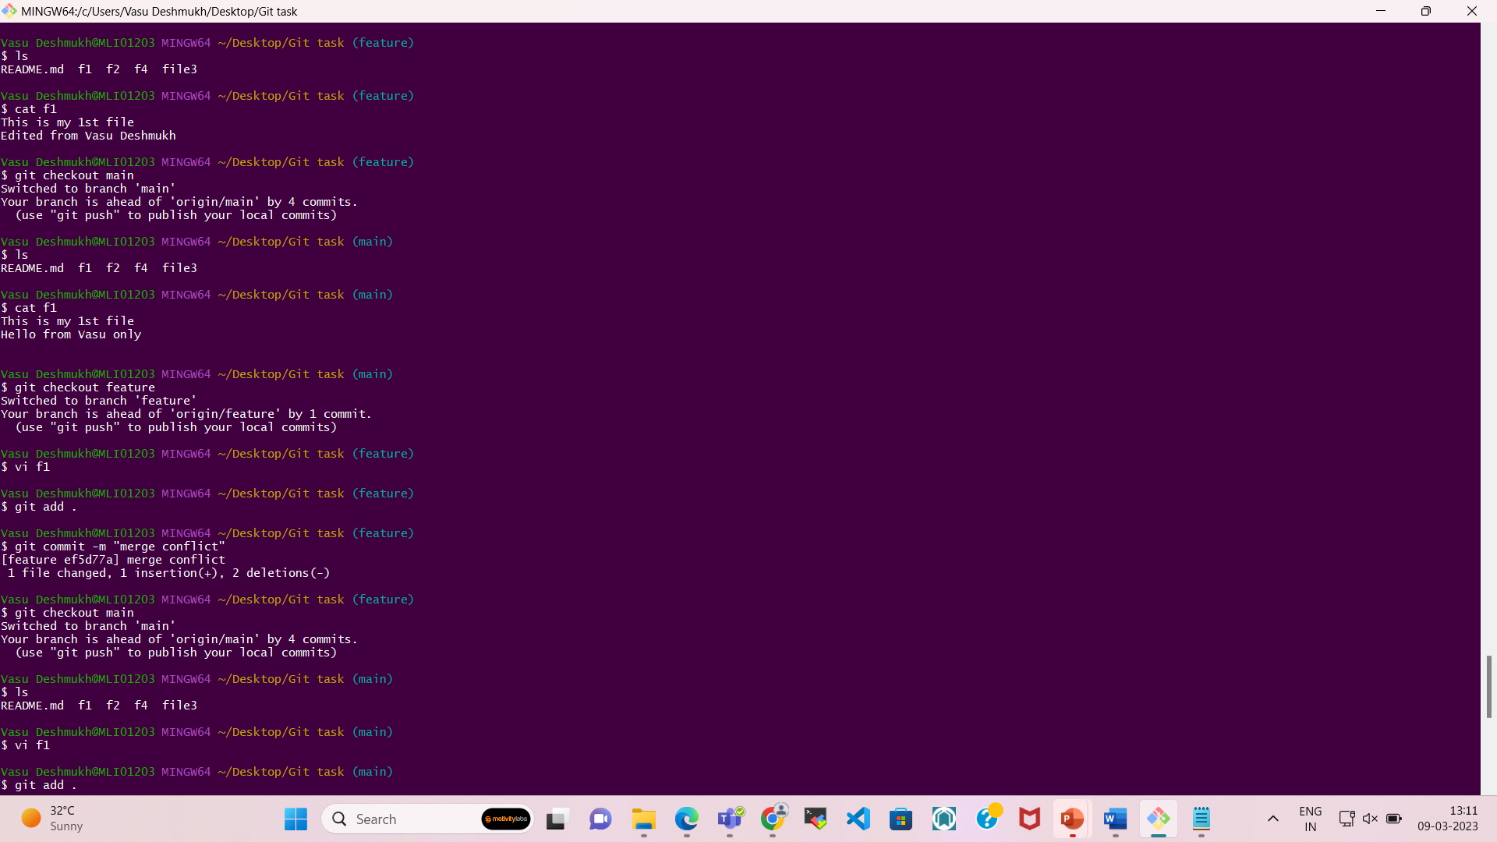

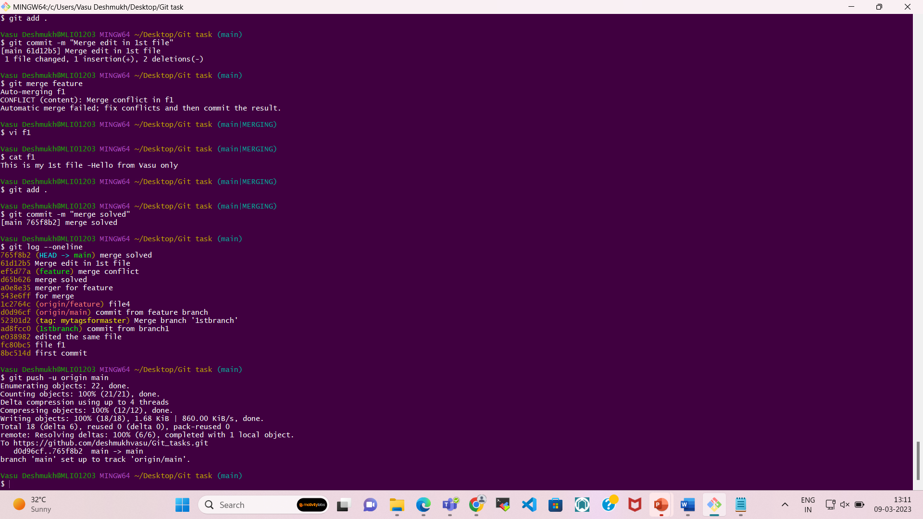

**Output**

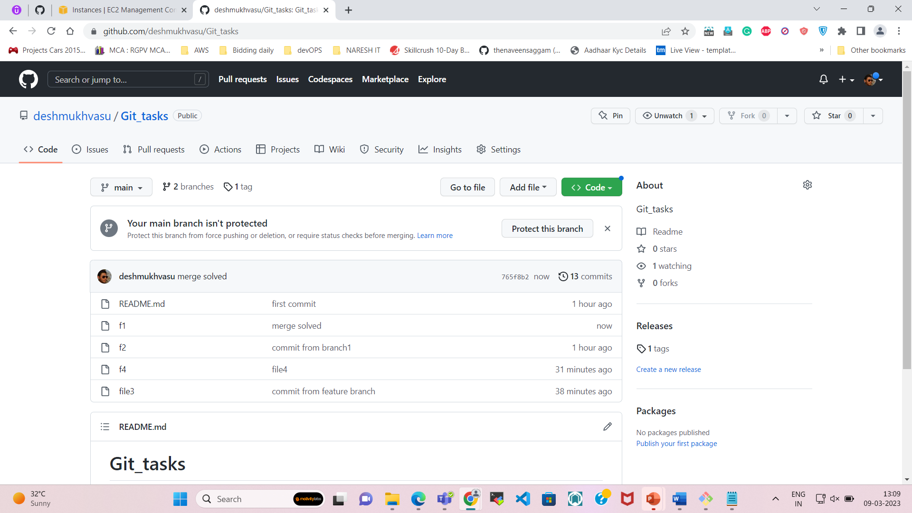

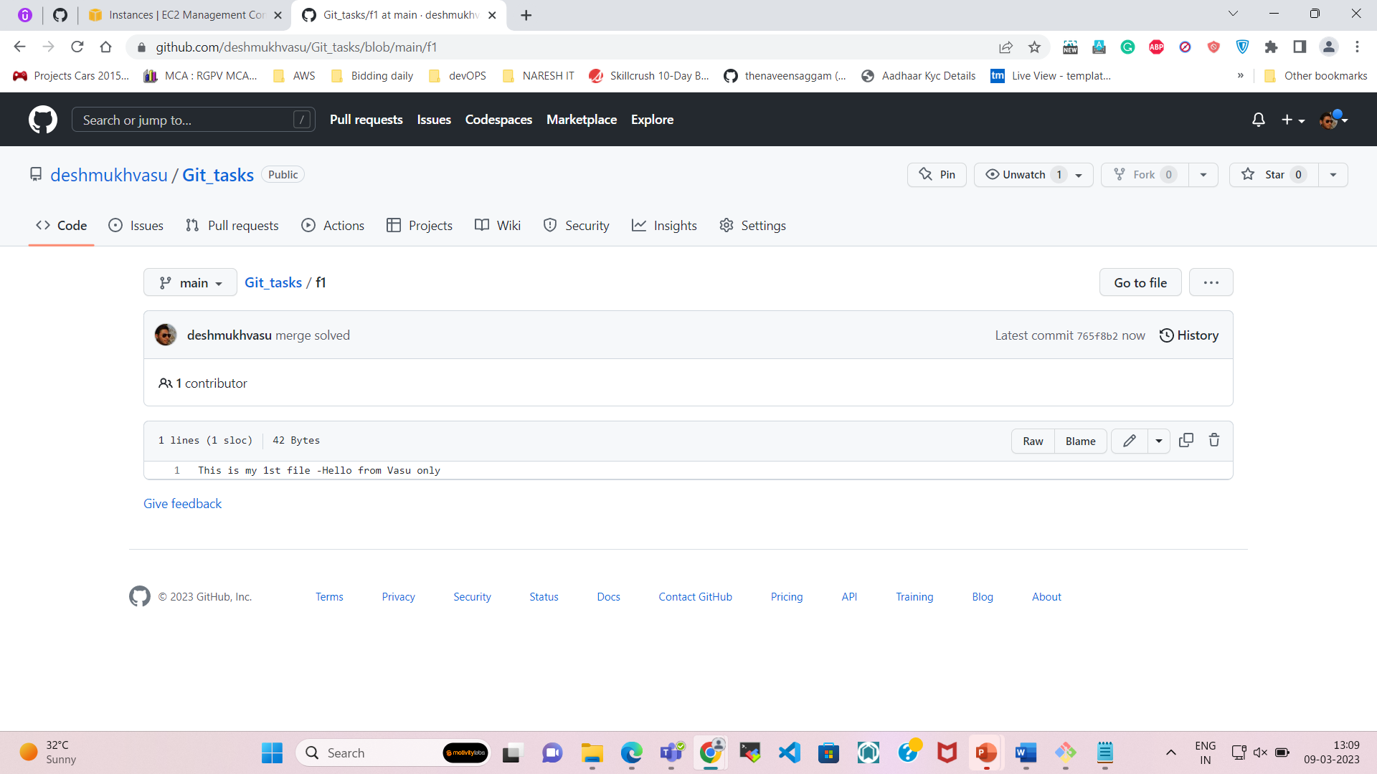

**Now Merge Conflict is solved.**

13. Delete the new branch.

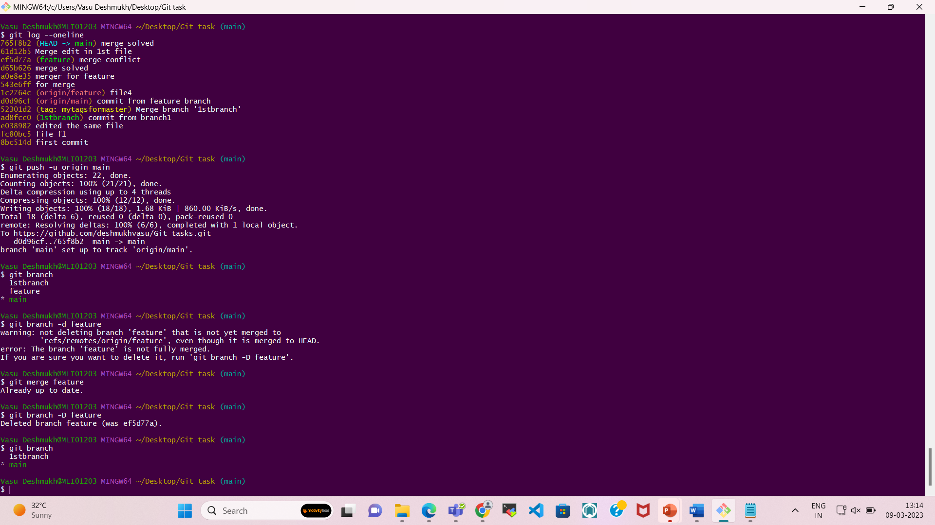

**==========================================================================================================================================================================**

Assignment: 2

Assume you are working on a project with other developers, and you have the following scenario:

There is a master branch, which is always in a deployable state.

There is a development branch, where all new features are developed.

There is a bugfix branch, where all bug fixes are made.

You have just finished working on a new feature on the development branch and have committed your changes.

You realize that there is a critical bug on the master branch that needs to be fixed immediately.

1. Create a new branch called bugfix and switch to it.

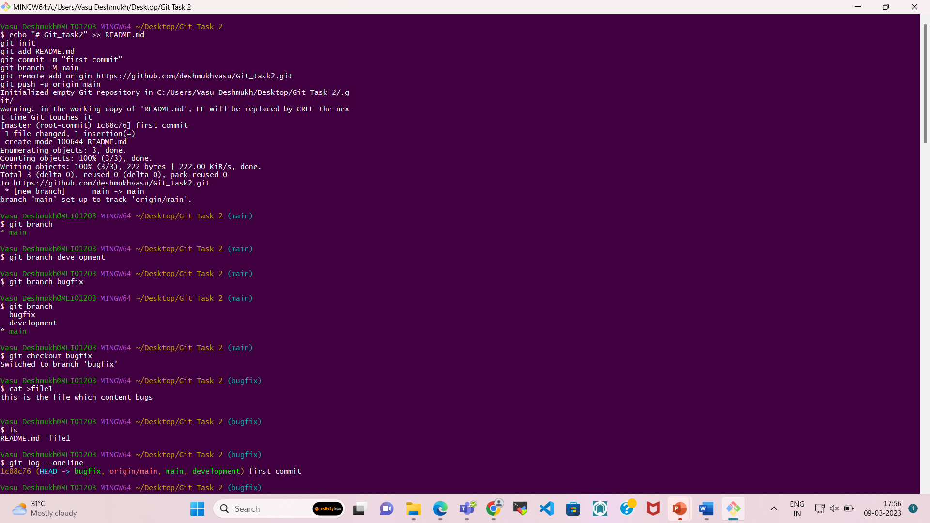

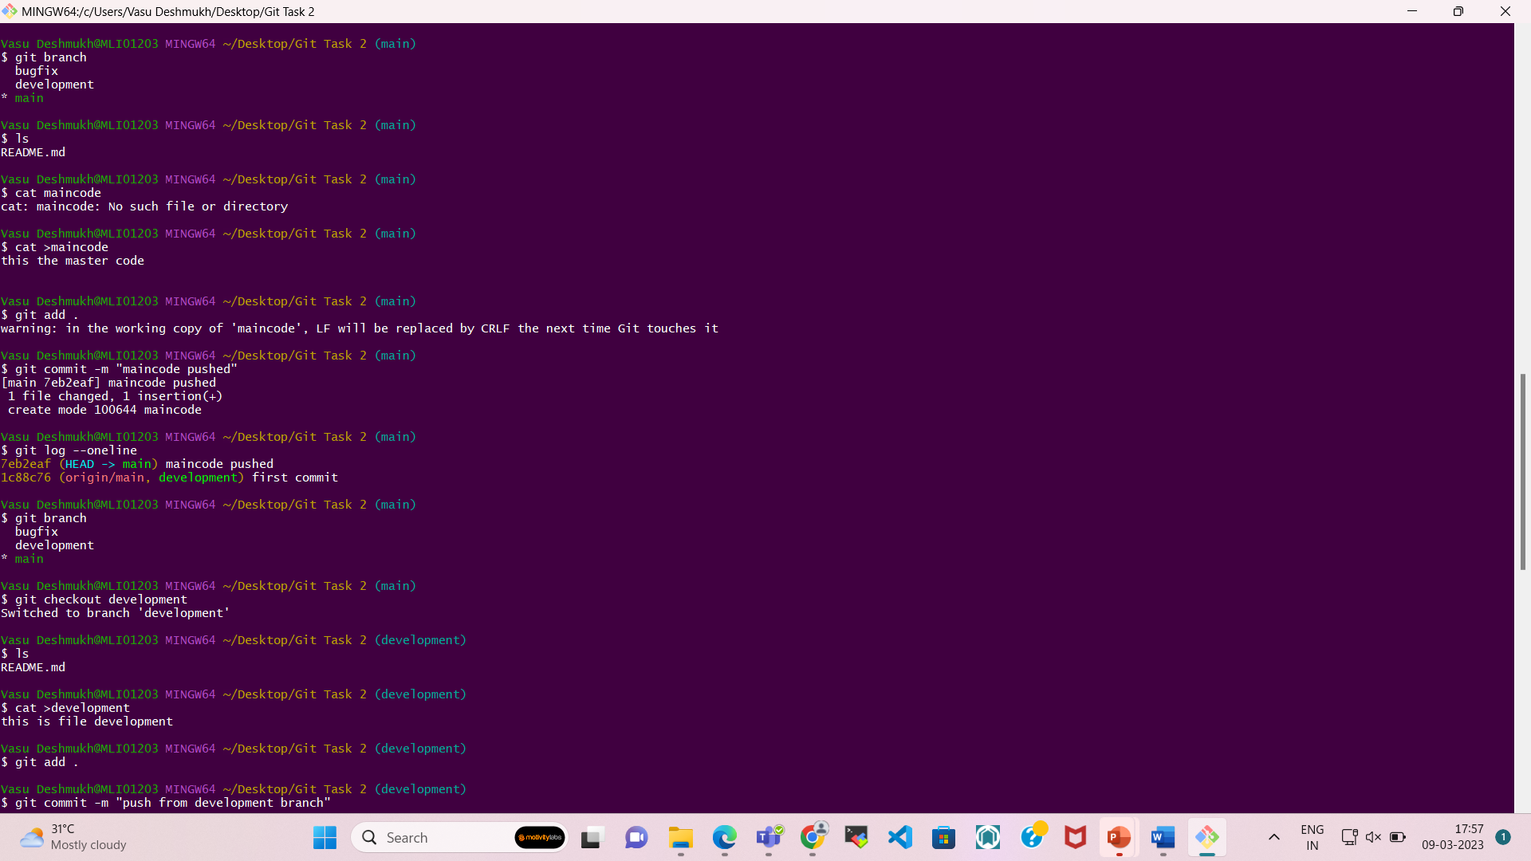

1. Cherry-pick the commit with the bug fix from the master branch onto the bugfix branch.

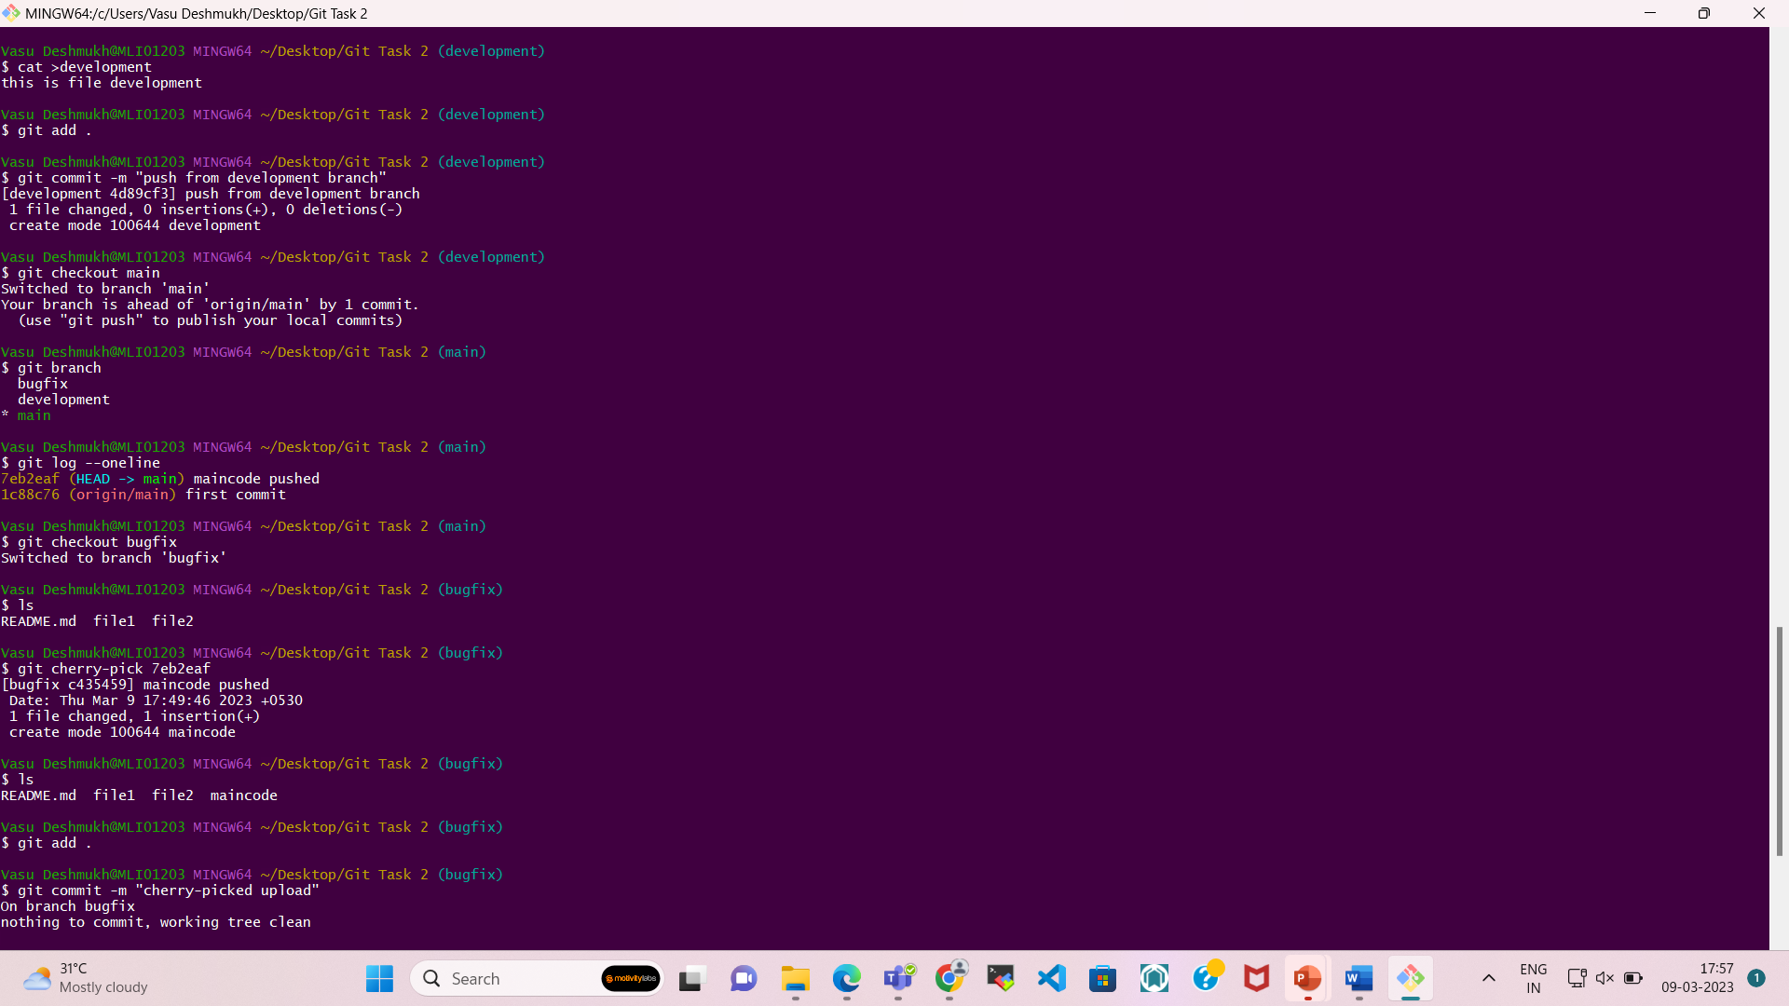

1. Push the bugfix branch to the remote repository.

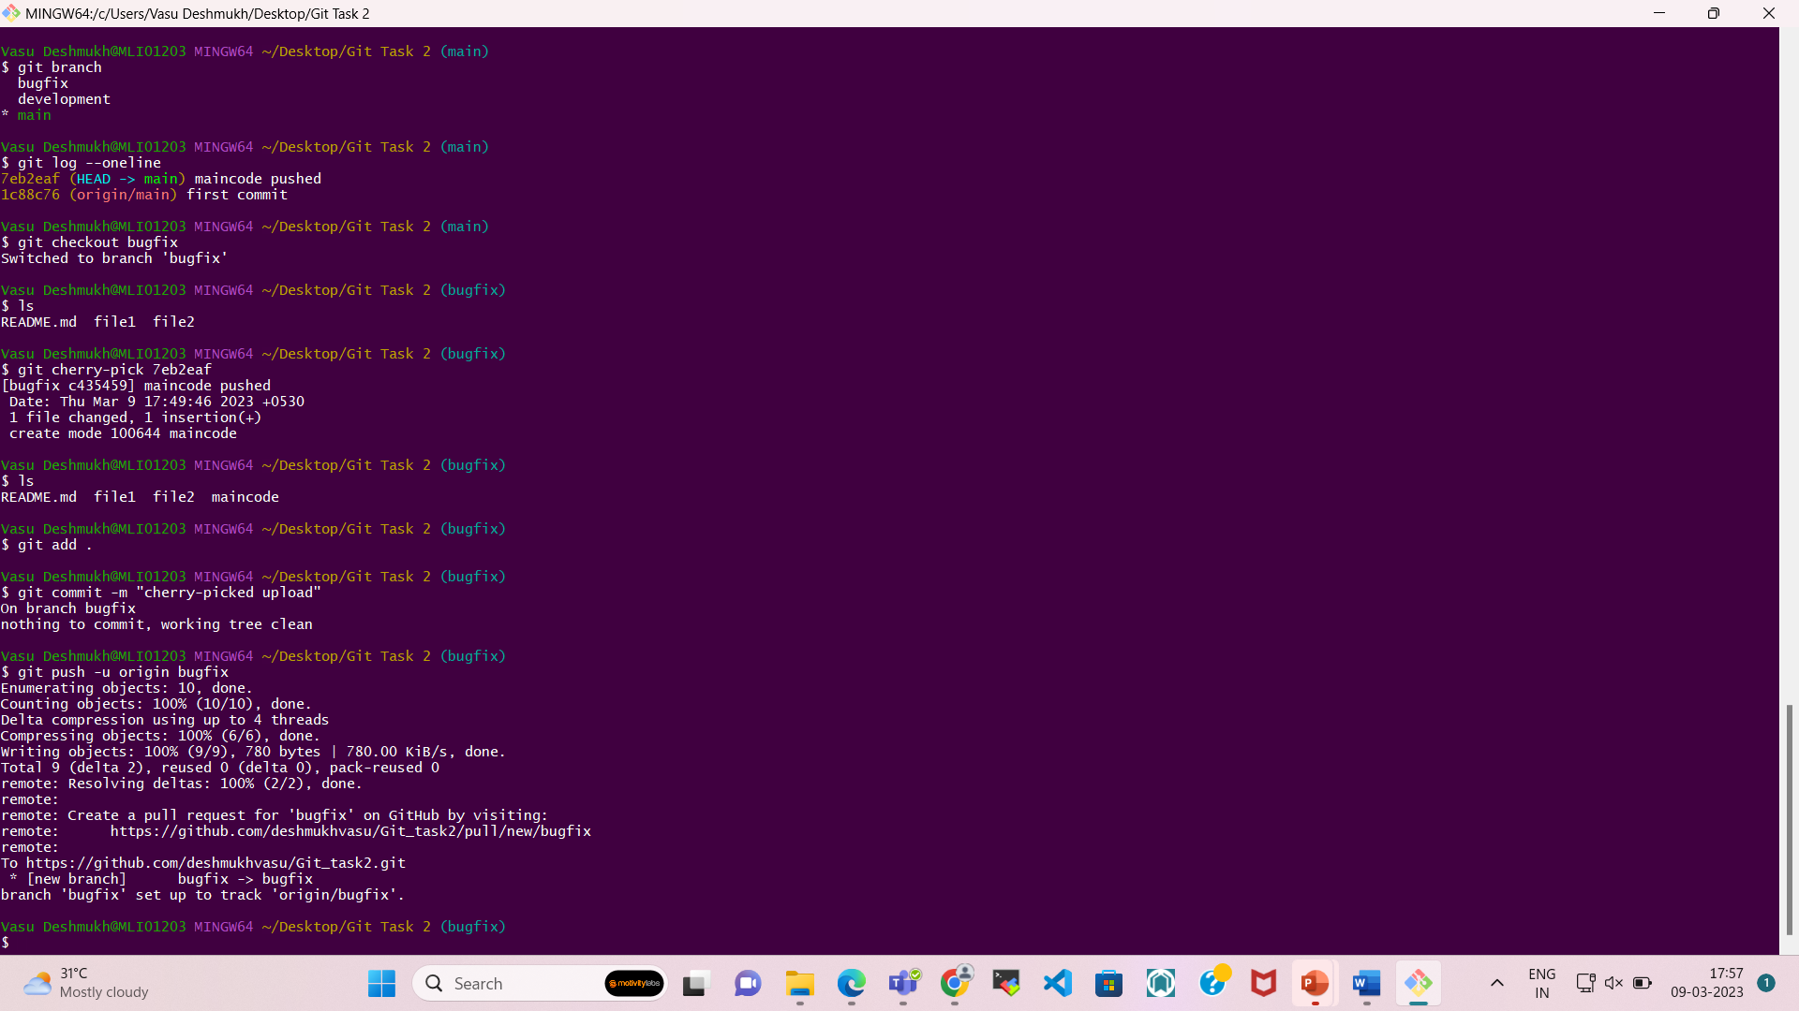

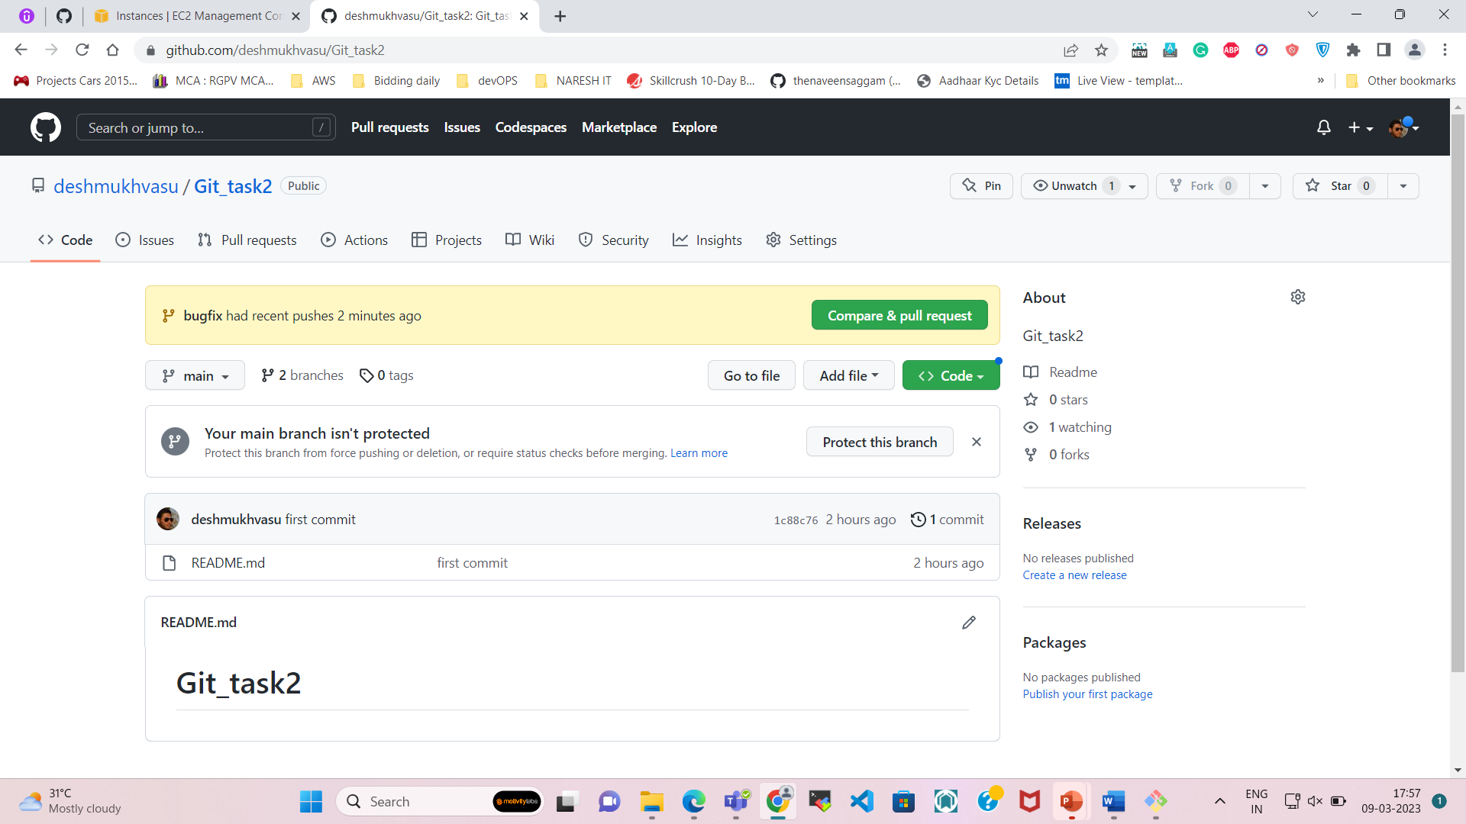

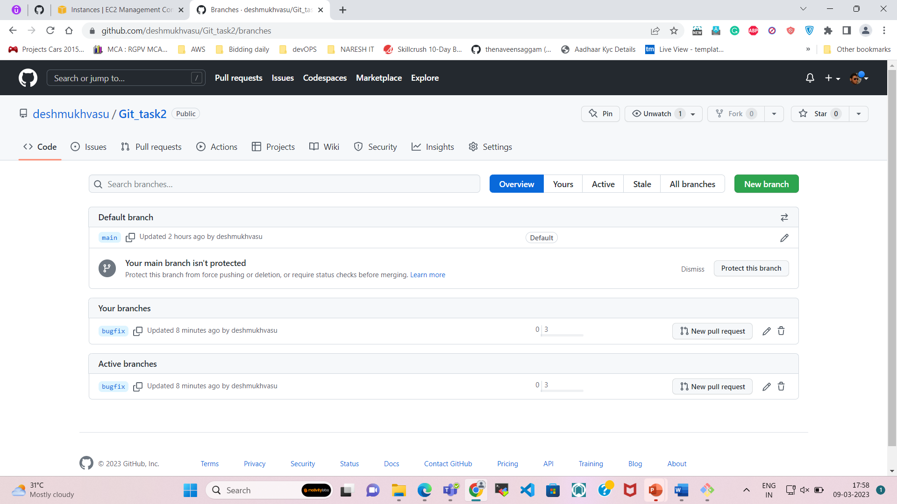

1. Switch back to the development branch and stash your changes.

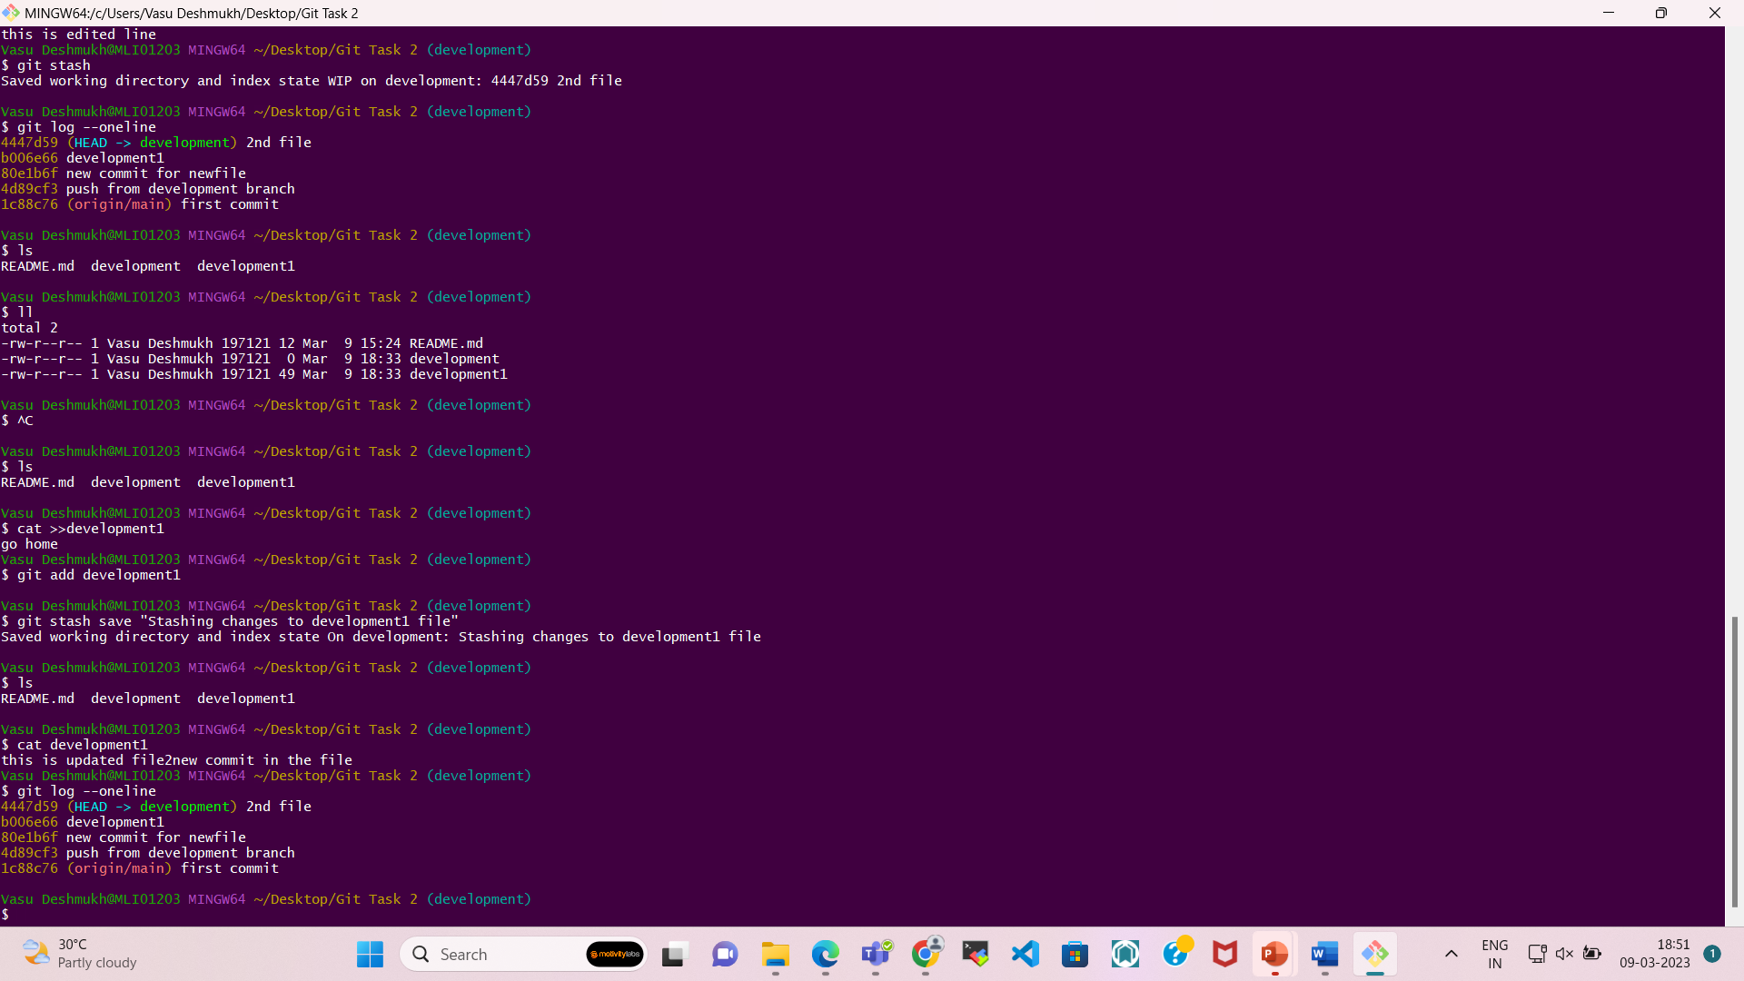

1. Switch to the master branch and revert the commit that introduced the bug.

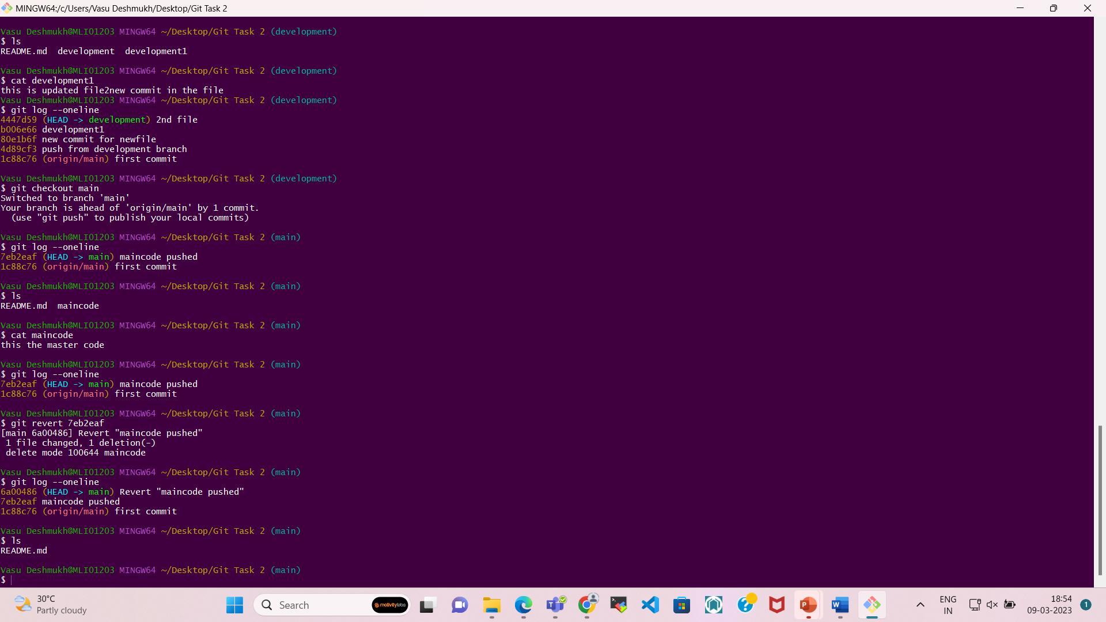

1. Push the changes to the master branch to the remote repository.



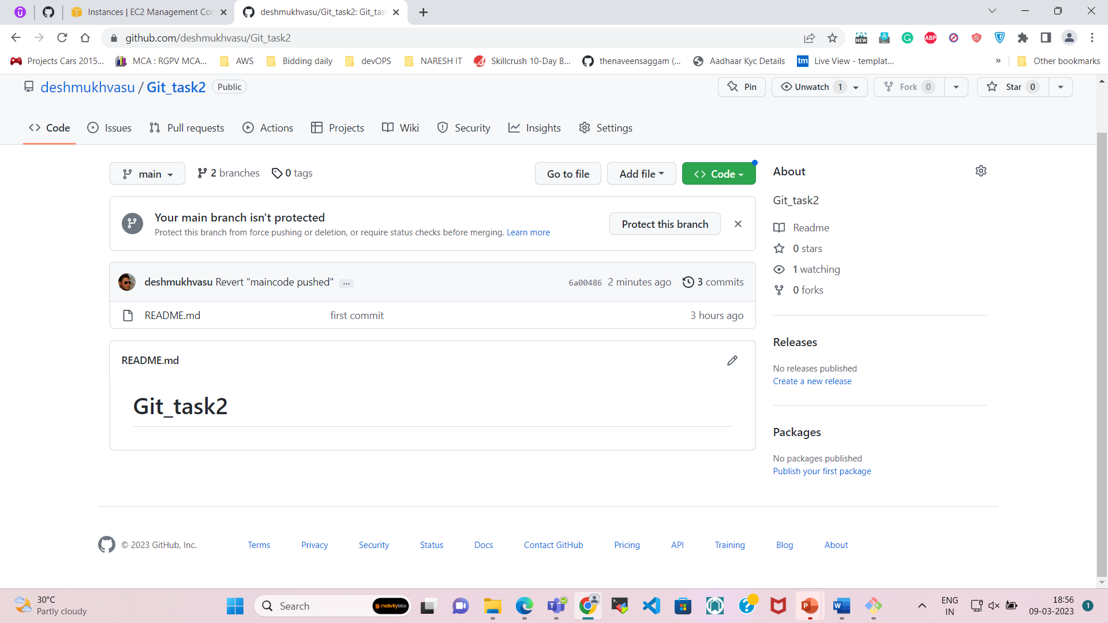

1. Switch back to the development branch and apply the stash.

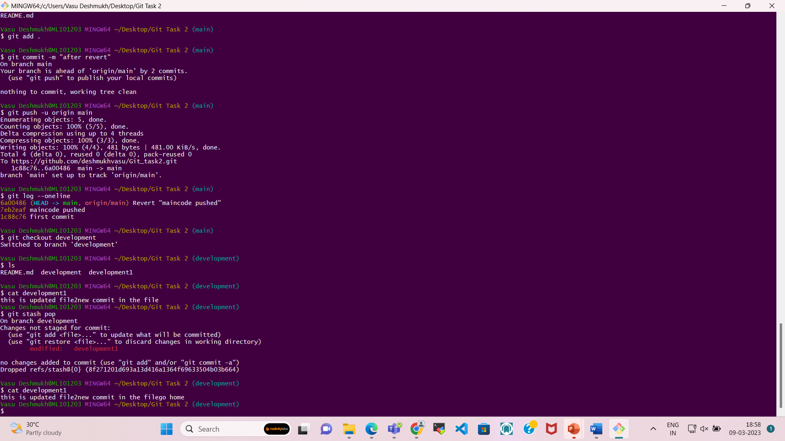

1. Commit your changes and push them to the development branch.

